**NATIONAL PYGMY HIPPO DAY CELEBRATION REPORT**

**MANO RIVER KONGO, GRAND CAPE MOUNT COUNTY, LIBERIA**

**APRIL 8, 2022**

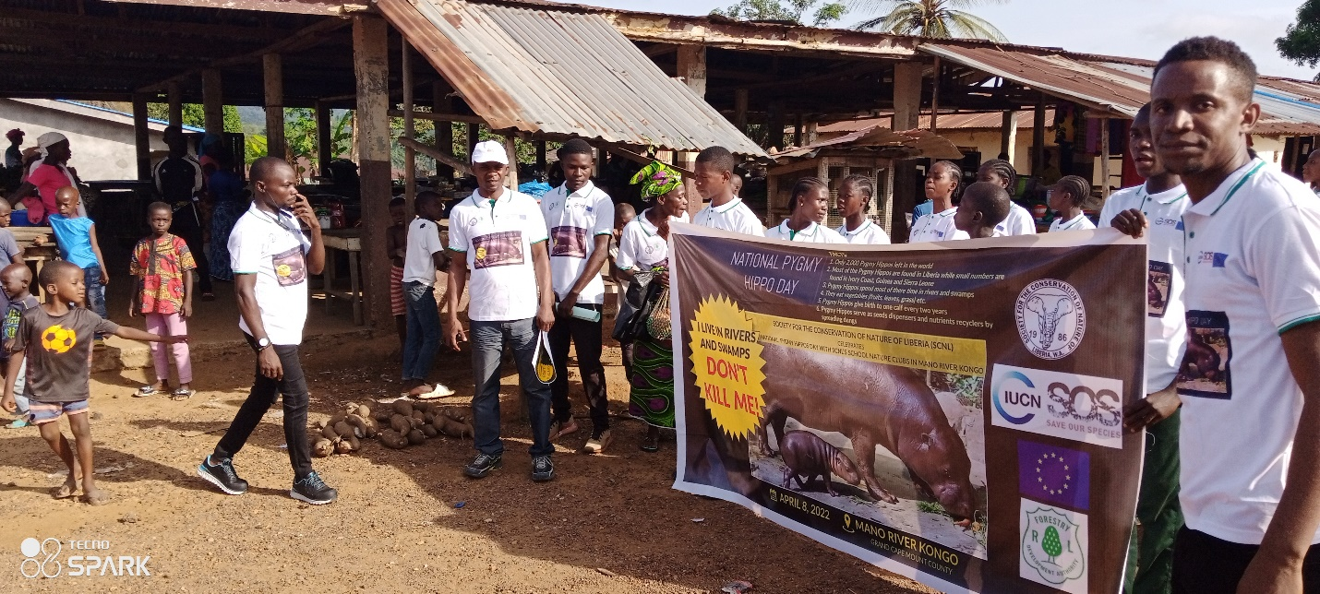

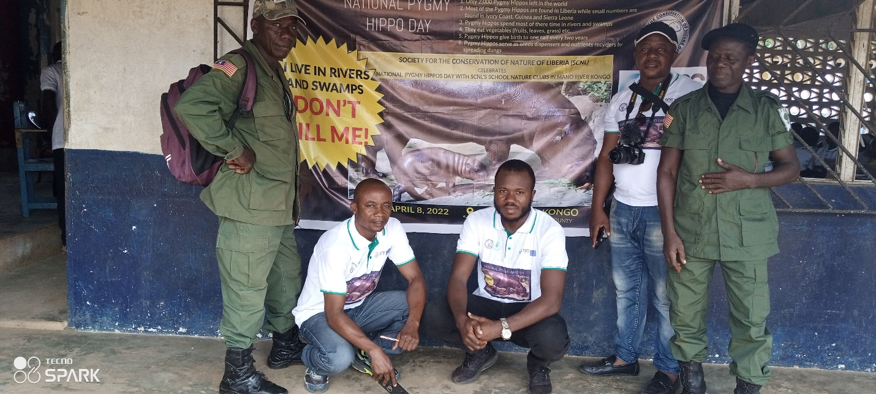

**BACKGROUND:**

National Pygmy Hippo Day is created to raise awareness about the species, which has been classified as an endangered species. The Zoological Society of London deemed this to be the case, estimating that there are only roughly 2,000 of these species left in the wild today. This is a small number, and it is declining.

There are a number of reasons for the decline in the number of pygmy hippos today. This includes that they are being **hunted for bushmeat** and **their natural habitats are being destroye**d. There used to be a subspecies of pygmy hippos in Nigeria, but it is believed that these are now **extin**ct, as there have not been any sightings for decades now.

The threat to this species is a very real one, and so it is important that we take note of National Pygmy Hippo Day so that we can do everything in our power to protect these wild animals that need our help!

*Introduction:*

The National Pygmy Hippo Day celebration was organized by the Society for the Conservation of Nature of Liberia (SCNL) in Mano River Kongo, Grand Cape Mount County with funding from the IUCN/SOS project. The program held in Mano River Kongo was done with forty-two (42) SCNL’s School Nature Clubs (SNCs) members from the Nuru Islamic Elementary School and Samuel R. Siaffa Elementary and Junior High School along with stakeholders of Porkpa District Paramount chief, Mano River Town Chief and General Town Chief as well as two (2) FDA rangers attended the occasion. The day was graced in two ways: outdoor- where students and participants paraded the principal street of Mono River Kongo town and through the general markets to show demonstrate awareness through flyers with facts about the Pygmy Hippps and later ended the day with an indoor program- was formally done within the Samuel R. Siaffa School with self-introduction, remarks, PowerPoint presentation of the National Pygmy Hippo Day, prices were won by SNCs for answering the question. During the program, there was a Pygmy Hippo drawing competition by SNCs students the student was divided into a group of five, and the best group that will draw the Pygmy Hippo will win a prize, during the drawing competition two groups came out to be the best and the first group won the higher prize followed by the second winner.

**Methodology:**

* Outdoor activity (street parade)
* Indoor program
* National Pygmy Hippo Day talk presentation
* Question and answers on Pygmy Hippo competition
* Pygmy Hippo drawing competition
* Remark by stakeholder

**ACTIVITIES:**

Outdoor Program: On April 8, 2022, Team from SCNL head office in Monrovia joined forty-two (42) SCNL’s SNCs in Mano River Kongo along with some communities’ members to celebrate the National Pygmy Hippo Day which initially started with a street Parade from Samuel R. Siaffa Elementary and Junior High School out through communities and market places.

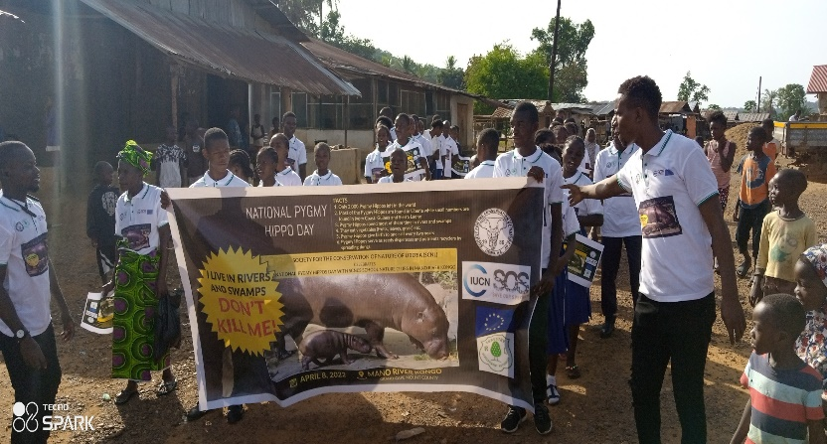During the parade, students showcase the importance of this day by singing a conservation song that appeals to the community on biodiversity and natural resources conservation for the present and future generations. Flyers with facts about Pygmy Hippos were shared with the community and marketers. The inhabitants of Mano River Kongo grew to the extent of joining the awareness raised on Pygmy Hippos Day.

The outdoor program awareness conducted climax with all the SNCs students and local leaders’ participations marching in the School Hall or Samuel R. Siaffa for the indoor program.

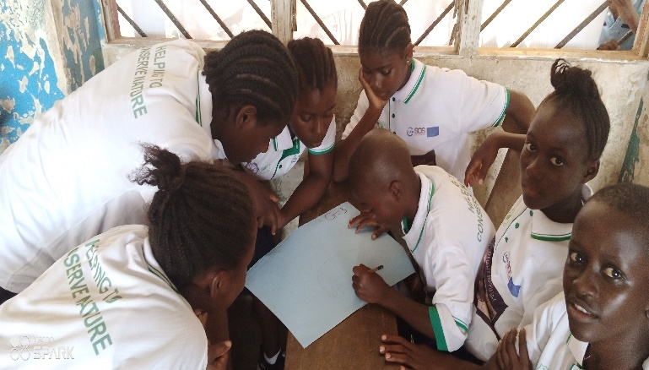Indoor Program: This occasion brought together many stakeholders Paramount chief Town chief and General Town chief, with FDA rangers and forty-two(42) SNCs students of Mano River Kongo to grace the program. The program started with an opening prayer from a volunteer, welcome remarks from the Town chief, overview of the Pygmy Hippo Day celebration by Mr. Emmanuel M. Loqueh, IUCN/SOS/SCNL Project Coordinator who arbore the listening audience with the facts sheet of Pygmy Hippos in the World.

Hence, the program agenda after the overview of the program continues with a PowerPoint Presentation on the National Pygmy Hippo Day celebration, Theme: Talk to Someone About Pygmy Hippo. This presentation encompasses background about the discoveries of Pygmy Hippos in Liberia (1911-1912) in Grand Cape Mount County and Later taking to Dublin, Ireland, and Germany respectively. It was said by Johnson G. Koikoi, Environmental Education Officer/SCNL who proxy for the Science and Conservation Coordinator/SCNL that these species are mostly found in Liberia with reference to studies done by the Zoological Society of London. ***Messages concerning the protection of Pygmy Hippos:***

* Pygmy Hippos are a small population
* You can only see them in the wild around West Africa, especially in Liberia
* Do not kill it for bushmeat
* Do not destroy the habitat
* Do not set trap for Pygmy Hippos

During the program, SCNL’s SNCs had a group of five (5) competitions to draw the exact/finest Pygmy Hippo which was won by group three (3) followed by an envelope. The second phase of the competition was also carried on by posted questions answered by individuals who will be the first to provide information on the facts regarding the Pygmy Hippos. The students won individual prices per answer hundred (100) Liberian Dollars. Some won 2-3 hundred Liberian Dollars by answering two (2) or more answers about Pygmy Hippos facts.

**Challenges:**

* No availability of GSM network coverage in the project landscape led to limited publicity through mobile phones prior to the National Pygmy Hippo Day
* The lack of a functional Radio Station in Mano River Kongo caused the publicity of the National Pygmy Hippos Day celebration to not go beyond Mano River surrounding communities
* Limited quarterly awareness of the facts and importance of the Pygmy Hippos day to the communities has led to the inhabitants of Kongo not being knowing of the role Pygmy Hippos play in the ecosystem

**Lesson Learned:**

The citizens/SNCs of Mano River Kongo shared the cause of raising awareness on Pygmy Hippos only when they were motivated by the publicity made by SCNL through T-Shirts, flyers, Banner, PowerPoint Presentation, Parade with kids as well as the local stakeholders’ participation in the process.

**Conclusions & Recommendations**:

The National Pygmy Hippo Day celebration was attended by forty-two (42) SCNL Nature Club students from the two (2) schools (Samuel R. Siaffa Elementary & Junior High and Nuru Islamic) in Mano River Kongo, with SCNL staff, SCNL, two (2) Forestry Development Authority (FDA) Rangers, General Town Chief and Town chief of Mano River Kongo as well as some community members. The program activities were done both (outdoor parade and indoor formal program) that constitute remarks and PowerPoint Presentation about Pygmy Hippos Status and importance in respect to the day. Everyone was physically joined in the National Pygmy Hippos Day celebration and awareness elements. SNCs won prizes for answering questions about the Pygmy Hippos. ***Considering the outputs and challenges***: It is recommended that going forward, a monthly or quarterly awareness raising of such should be done to enhance the sustainability of Pygmy Hippos in Liberia and its neighboring countries as well as other species on the IUCN lists.

**Attendance for the program**

