**Rulebook**

**Role-play on land and natural resource use and landscape conflict analysis Yoko / Nanga-Eboko**

The rules presented below were built before the first field tests. **One of the principles of this tool is to have the ability to adapt to the feedback of the participants and the animation team**. Indeed, the construction of the rules of the game is a step in itself in the construction of the expected scenarios. They are therefore likely to evolve during the first contacts with the field.

1. Game Content
   1. Parcels

The board is made up of hexagonal tiles (modular board), placed by the participants. We will call them "parcels," and their color indicates the level of degradation and associated productivity, which can also be understood as the quality and quantity of natural resources.

For this adaptation, each parcel can be flipped to show its degradation according to the following scheme:

-Double-sided parcels: Dark green (mature secondary forest) / Light green (young secondary forest, in the process of degradation)

- Double-sided parcels: Red (shrubland or wooded savanna) / Wood color (degraded grassland savanna)

- Double-sided parcels: Blue (watercourses) / Speckled blue (polluted watercourses)

- Double-sided parcels: Gray (urban areas) / Purple (sacred sites)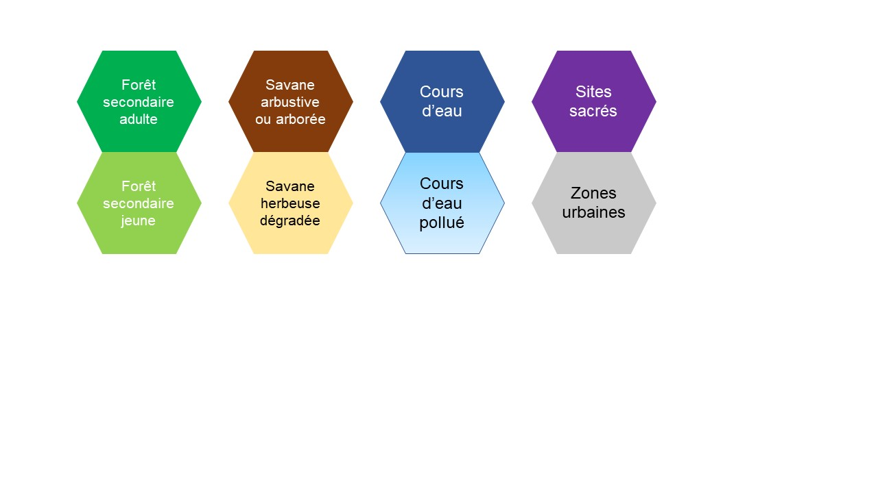

* 1. The different tokens

|  |  |  |
| --- | --- | --- |
| **Token** | **Name** | **Description** |
| Colorful wooden tree pawn 36x25x10 mm | Wood-coloured trees | Firewood/harvesting |
| Colorful wooden tree pawn 36x25x10 mm | Green trees | FLR: Reforestation/Agroforestry/Forestry |
|  | Bushfire tokens | Used to burn a parcel to promote grass regrowth, slash-and-burn agriculture or grazing |
| Wooden cow game pawn 25 x 17 x 8 mm | Ox Tokens | To be introduced when playing the role of the large transhumant or if there is a grazing area in the village |
| 50 Large Natural Wood Sticks 15 x 1.8 x 0.18 cm DIY and Games | Transhumance corridor | To indicate the location of the transhumance corridors/paint some of these rods to mark the roads |
| 6 black wooden animal pawns for games | Wildlife Tokens | Place in the secondary forest (yellow and adult) and shrub savannah (dark green/light and brown squares) parcels. |
|  | Fish Tokens | For fishing in rivers |
| Black wooden cubes 0.8 cm. 8x8x8 mm lot 20 | Black Cubes Resources | Represent the amount of natural resources present on the parcel and which, once harvested by the participants through different activities, become their earnings that allow them to feed their families and invest. |
| White wooden cylinder 15 mm x 12.8 mm individually | Watering Hole Tokens | Symbolize water points (boreholes, ponds, wells). |
|  | Set of additional counters in different shapes and colors | They are used to introduce any new elements at the request of the participants. |
| Light Green Wood Token Tokens 15 x 4 mm Set of 20 for Games | Token agricultural activity | To be placed on the parcels by the players. On these tokens are drawn different symbols for each player |
| Purple Wood Token Tokens 15 x 4 mm Set of 20 for Games | Token breeding activity | To be placed on the parcels by the players. On these tokens are drawn different symbols for each player |
|  | Token hunting/fishing activity | To be placed on the parcels by the players. On these tokens are drawn different symbols for each player |
| Brown Wood Token Tokens15 x 4 mm Set of 20 for Games | Token activity wood cutting | To be placed on the parcels by the players. On these tokens are drawn different symbols for each player |
| Yellow Wood Token Tokens 15 x 4 mm set of 20 for games | NWFP/pharmacopoeia harvesting activity token | To be placed on the parcels by the players. On these tokens are drawn different symbols for each player |

* 1. **Maps**
* Each player has a family composed of a certain number of members, represented by a number of "family tags," which may differ among participants (distribute to the players a total number of family members equal to the number of parcels on the board, to be shared unevenly among the players). Participants will thus have a certain number of "family tags" in front of them. Each player can place on the board as many activities as they have family members. The family tag should reflect the average household size in the villages (see ESE).

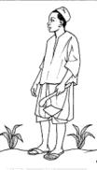

* The **difficulty** cards are to use in case of conflicts, problems with livestock and lack of natural resources.



* White hexagonal cardboard tiles placed on the parcel to indicate that it is no longer usable.

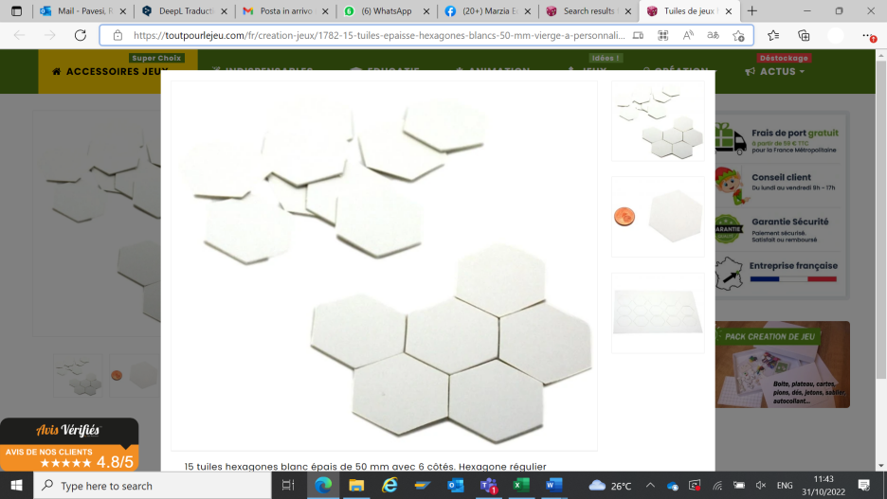

* 1. The dice

The introduction of dice makes it possible to bring a dose of uncertainty, which is also present in reality, and to materialize the notion of risk.

|  |  |
| --- | --- |
| **Name** | **Description** |
| A "fire dice" to decide whether or not bushfires spread. | 3 sides with the fire symbol, 3 sides without, (probability 50%) |
| A "dispatch dice" to determine the number of fish caught | If the result is:  1 : 1 fish caught (prob. 17%)  2.3: 2 fish caught (prob. 33%)  4,5,6: 3 fish caught (prob. 50%) |
| A "hunting dice" to find out the number of animals caught | If the result is:  1 : 1 animal hunted (prob. 17%)  2.3: 2 animals hunted (prob. 33%)  4,5,6: 3 animals hunted (prob. 50%) |
| A damages dice of wildlife or livestock on the fields. | 3 sides damage and 3 sides white, 50% damage probability |

1. Tray Installation

The board is constructed using tiles (parcels) (between 40 and 50 per board) with the participants, and the terrain can be represented by stacking multiple tiles.

The board will consist of:

* **Hexagonal tiles** in yellow, red, dark green/light green, and blue/speckled blue, representing parcels and watercourses (according to the participants' preferences).
* **Notable landmarks** for orientation (villages, sacred sites, orchards, etc.).
* **Wood-colored trees** (for exploitation) on the parcels: dark green (maximum of 3), light green (maximum of 2), and red (maximum of 1). Yellow parcels do not have trees.
* **Wildlife tokens** (maximum of 3 per parcel) in mature forest and yellow areas.
* **Fish tokens** (maximum of 3 per parcel) in river zones.
* **Water point tokens**, placed according to the participants' preferences.
* **Small black cubes** on each parcel representing the quantity of natural resources available. These resources, once harvested by participants through various activities, become their gains, allowing them to feed their family and invest. The initial number of resources is arranged according to the following table, with blue parcels containing no resource cubes.

Table 1 Resource Placement Rule

|  |  |  |
| --- | --- | --- |
| **Parcel colour** | **Resources** | **Trees** |
| Dark green parcels | 3 | 3 |
| Light green parcels | 2 | 2 |
| Red parcels | 2 | 1 |
| Wood-coloured parcels | 1 |  |

The facilitators and participants will have other data according to their judgements not represented on the board and will be able to use it to push the players to develop their ideas: possible conflicts, rules of use or governance, areas dedicated to certain specific activities.

1. Tour and event schedule

A year is broken down into four (4) rounds of play, a long rainy season, a long dry season (the season when there is the most degradation), a small rainy season and a small dry season

* 1. Resource Regeneration

In each rainy season (and not in the dry season):

* The parcels are refilled in resource cubes according to their color,
* Fish double up to a maximum of 3 fish per parcel
* Wild animals are not eliminated or regenerated but disperse into adjacent parcels
* Trees do not reproduce naturally

Table 2 Resource renewal rule

|  |  |  |
| --- | --- | --- |
| **Parcel colour** | **Resources** | **Pisces** |
| Dark green parcels | +3 and +1/tree | - |
| Light green parcels | +2 and +1/tree | - |
| Red parcels | +1 and +1/tree | - |
| Wood-coloured parcels | +1 | - |
| Blue parcels | - | Double max 3 |
| Parcels with blue mottles | - | - |

* 1. Activity Placement and Conflicts
     1. **Activities**

Each season the players arrange their activities on the board, according to the number of members in their family (family labels)

* **Farming**: If the player wants to farm, they place a yellow "farming token" on a parcel that must first be cleared (with or without fire). Farming earns 2 resources max taken from the parcel + 1 resource for each tree cut down but not if they use fire.
* **Breeding**: The player has a red "breeding token" on the parcel. Breeding yields 2 resources max. In the dry season, livestock farming requires a water point on the parcel or an adjoining parcel, unless it is on the bank of the river
* **NWFP Picking:** The player places a green "picking token" on a parcel. Picking yields 1 resource in all seasons, taken from the parcel.
* **Hunting:** The player places a purple "hunting token" on a parcel where wildlife tokens are present. He rolls the chase die and takes the number of black cubes corresponding to the number of animals hunted.
* **Fishing**: the player places a purple "peach token" on a blue parcel where fish tokens are present. The dice are drawn and the number of black cubes corresponding to the number of fish caught is taken.
* **Wood cutting:** wood cutting is practiced on parcels with wood-coloured trees. For each tree cut down and removed from the parcel, you earn 1 black resource cube from the bank.

Table 3 Business Investment and Earnings Rule

|  |  |  |  |
| --- | --- | --- | --- |
| **Activities** | **Conditions** | **Resource Cube Gains** | **Regeneration** |
| **Agriculture** | Clean up the parcel | 2 resources present on the parcel + 1 tree resource cut down | Rainy season/bush fires that bring resources |
| **Breeding** | A water point on the parcel or adjoining parcel in the dry season | 2 resources present on the parcel | Rainy season/bush fires that bring resources |
| **Fishing** | Fish tokens present on the parcel | Result of the "fishing dice", resources drawn from the bank | Fish double in each rainy season |
| **Wood cutting** | Trees present on the parcel | 1 per tree cut, resources from the bank | Reforestation |
| **Hunting** | Wildlife token present on the parcel | Result of the "hunting dice", resources drawn from the bank | The tokens of wild animals are not eliminated but disperse into adjacent parcels |
| **NTFP** | Dark/light green parcels | 1 resource present on the parcel | Rainy season/bush fires that bring resources |

* + 1. Conflicts and special events
* Livestock Damage: If during a turn, a player's breeding token is on a cultivated parcel, you roll the dice to decide if the breeding has invaded the land and in this case the farmer of that parcel gives 2 of his harvested resources to the breeder.
* Wildlife damage: If the field is located on a parcel where wildlife tokens are present, the crop is destroyed.
* Wildlife movement: The wildlife token can change parcels, if too much pressure/tree cutting/fires. When all the trees in a parcel are cut, and when fire is applied to the parcel, wildlife flees.
  + 1. Bush fires

Players have the ability to set fire to:

* Clean and install a field (remove the trees from the parcel). This fire is generally controlled and does not spread.
* For hunting: regenerate vegetation to attract animal tokens to the parcel, but can spread in the dry season
* For grazing in the dry season to promote regrowth, with the risk of propagation (but this practice is mainly used by large transhumant herders, *see the role "Passage of a large transhumant").*

In any case, a fire brings 2 additional resources to the parcel, but in the event of a spread, the trees and resources around the parcel are affected and the yellow (agriculture), green (picking) and brown (wood cutting) activity tokens present on these parcels are removed.

* 1. **Defacement/Restoration**
* From the dry season onwards, a dark green parcel of land on which only one tree remains turns light green,
* From the dry season onwards, a light green or red parcel on which the trees have disappeared turns red or wood-coloured respectively,
* The facilitator can choose to degrade brown parcels when they are overused by agricultural or pastoral activities, hunting or crossed by frequent fires. It can also make wildlife and fish tokens disappear, or turn over "watercourse" parcels for pollution
* When a wood-coloured parcel deteriorates, a small white cardboard tile is placed on the parcel to indicate that it is no longer usable.
* The restoration of the parcels is carried out through various proposed FLR measures (*see FLR role*).
  1. Events/Roles
* Long rainy season:

Appointment by the players of a village chief or a traditional authority

* Long dry season:

Arrival of a transhumant: a facilitator takes on the role of a transhumant who arrives on the territory with X specific ox tokens and must negotiate with the chief to settle in the municipality. He lights bush fires and consumes the resources with his livestock. The facilitator can choose whether the burnt grassy (wood-coloured) savannah degrades and will no longer be able to receive resources (mark the parcels)

* Subsequent seasons (to be chosen according to the issues specific to the village where the workshop takes place, may also differ depending on the stage)

Arrival of a timber operator with a DDFOF/sub-prefect/head of post "authorization" to cut wood on a large scale in the forest

Arrival of an investor wishing to buy land for large cocoa plantations, negotiations with the sub-prefect and the village chief

Arrival of a fisherman for commercial fishing

Arrival of a hunter for commercial hunting

Arrival of an international organization that proposes to introduce FLR measures with a community project🡪, discussion to define reforestation areas and implementation of agroforestry/forestry systems and management methods.

* FLR (reforestation, agroforestry, forestry):

On a parcel the player can decide to implement FLR measures (reforestation, agroforestry or forestry) by adding green trees.

To implement an FLR measure, the player must spend one resource for each green tree they want to introduce into the parcel.

When FLR is declared (regeneration), the parcel begins to produce resources based on its colour and the number of green trees present.

When the parcel has produced 6 resources, it regenerates by changing color.

Cultivation, breeding, gathering and hunting activities can be carried out without cutting down green trees.

When the parcel turns light green, the green trees become wood-coloured.

* 1. Harvesting, feeding family and shopping

At the end of each season, players must provide for their families with the cubes collected (1 cube for 1 label in the bank). If they have excess cubes, they can use them as they see fit (help another villager, invest in a pond, fences, a green tree, etc.). If a player does not have enough resources to feed all the members of his family, he is dealt a red difficulty card.

During the harvest, the facilitator must point out:

* Conflicts between farmers and herders (on the same parcel)
* Conflicts between investors/timber loggers/large poachers/transhumant herders (roles) VS population (players)
* Competition for livestock and wildlife resources in the forest
* Wildlife damage (monkeys, redness) in the fields
* The regenerative effect of FLR measures
  1. Summary of all the actions

Rainy Season:

* (Population growth)
* Rain (recharges parcels with black cubes and wells with blue cubes)
* Placement of activities/controlled fires
* Random event roll
* Harvest
* Sanding/Degradation/Restoration
* Feed the family / difficulty cards
* Small debriefing: Did we succeed in this season individually? And at the territory level?

Dry Season

* Fish reproduction
* Placement of activities
* Event
* Harvest
* Sanding/Degradation/Restoration
* Feed the family / difficulty cards
* Small debriefing: Did we succeed in this season individually? And at the territory level?

1. Final restitution: passage on card/paper
   1. Debriefing

In the heat of the moment, after each season or each round on each set, the host will be able to do a short debriefing to find out how the participants did individually and what they think of what took place on the scale of their territory.

* Final Season: Must serve the purpose of the workshop
  + Discussing with people about conflict resolution: what proposals?
  + Discussing the problem of poaching, logging, etc.: what proposals?
  + Discuss with people the desired FLR measures in their territory?
  + Identification of proposals
  + Restitution to the other platforms, pooling of proposals