**“Smart Wetland” – Where Traditional Management Meets Innovation & Technology**

**Technical Review Summary of Potential IoT Application**

**Introduction**

The application of Internet of Things (IoT) devices has rapidly increased due to advancements in IoT technology and new wireless communication technologies. Under the Countryside Conservation Funding Scheme (CCFS), WWF-HK have started a two-year project in December 2022, namely the “Smart Wetland” – Where Traditional Management Meets Innovation & Technology. The “Smart Wetland” research activity aims at introducing and demonstrating the use of selected IoT devices with compliment to the wetland management framework of Mai Po Nature Reserve (MPNR). This technical review covers the selection justifications of each proposed device type according to the management requirements at MPNR. Data transmission network and three IoT applications including water level monitoring, water quality monitoring and buffalo tracking are covered in this technical review.

**Data Transmission Network**

Traditional sensors would each require a 4G connection to central servers. Considering the large number of the sensor this research need to deploy and nearly all sensor locations have no local power supply available, having 4G connection for all sensors will be very expensive and technically not possible. In this research, Government-Wide IoT Network (GWIN) developed by the Electrical and Mechanical Services Trading Fund (EMSTF) is adopted as this bi-directional Long Range (LoRa) network with low power consumption reduces the cost and complexity of the sensors installation in MPNR.

Gateway is the key infrastructure that dispenses wireless signal coverage for the sensor devices. With the joint site survey done by the staffs of WWF-HK and EMSD in March 2022, it was estimated that total three new GWIN gateways will be sufficient in covering the concerned area for the required sensor applications assuming that local power supplies will be available at the installation locations. Local power supply are available for two targeted locations for the installation of GWIN gateway, namely Peter Scott Field Studies Centre and Education Centre. The third targeted location, namely the Southern Hide, does not have local power supply and requires the support from an existing solar power system. The capacity of the solar power system should need to be upsized to cater for the additional loading of the GWIN gateway.

*Map 1. Proposed sensor and GWIN gateway installation locations in MPNR*

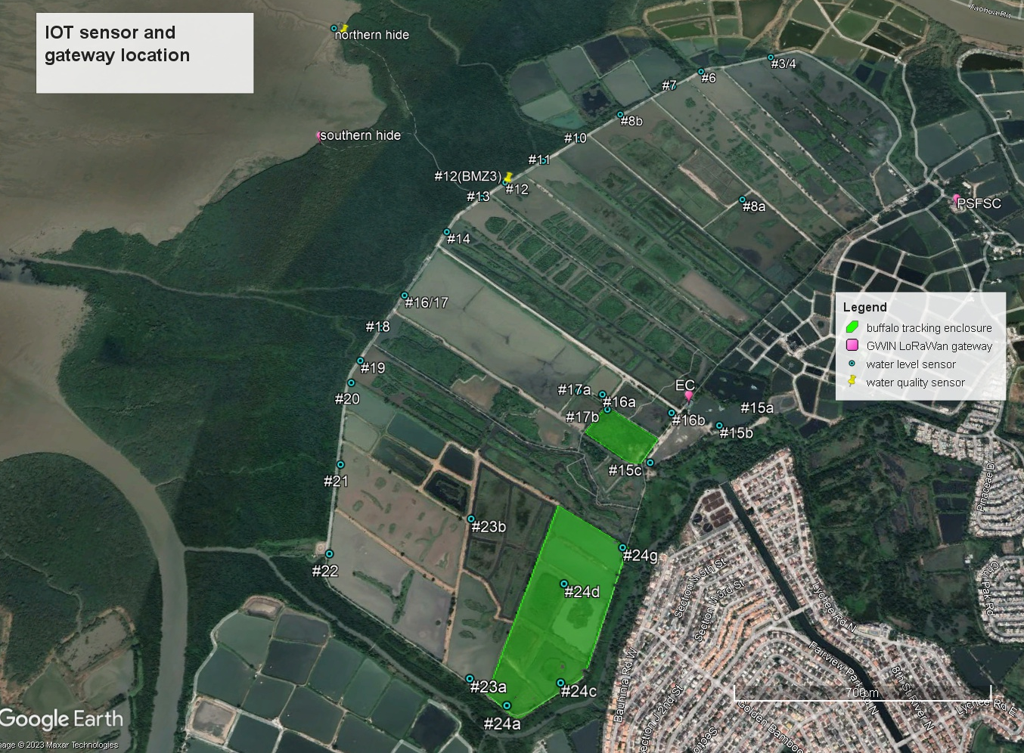

In addition, there are existing GWIN gateways installed in the surrounding area of MPNR which should further strengthen the GWIN signal coverage and sensors communication within MPNR.

*Map 2. Existing GWIN gateway locations surrounding area of MPNR (EMSD, April 2022)*

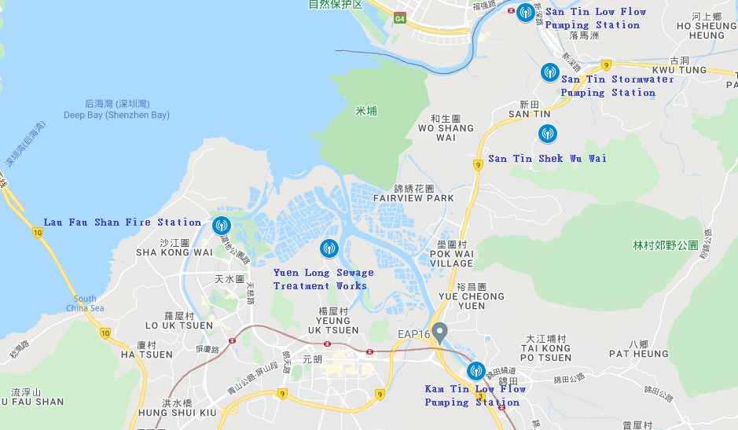

**Water Level Monitoring**

The objective of water level monitoring in MPNR is to facilitate effective management of wetland water levels subject to multiple management requirements. Examples are to ensure the availability of appropriate roost sites for waterbirds throughout the Inner Deep Bay tidal cycle, and to sufficiently flood the wetland vegetation to inhibit further terrestrialisation in wetland.

Three brand/models of water level sensor are selected for the review regarding its specifications including wireless technology, sensing technology, measurement range, resolution, accuracy, battery lifetime estimation, International Protection (IP) rating and configuration method. Specifications of the three models are listed in the following table for comparison purpose:

|  |  |  |  |
| --- | --- | --- | --- |
| *Brand* | *Decentlab* | *Dingtek* | *ELSYS* |
|  |  |  |  |
| *Model* | *DL-MBX-001* | *DC410* | *ELT Ultrasonic* |
| *Wireless technology* | *LoRaWAN* | *LoRaWAN* | *LoRaWAN* |
| *Sensing technology* | *Ultrasonic* | *Ultrasonic* | *Ultrasonic* |
| *Measurement range* | *0.5 - 10m* | *0.25 - 8m* | *0.3 - 5m* |
| *Resolution* | *1mm* | *1mm* | *1mm* |
| *Accuracy* | *1mm@1m* | *3mm@1m* | *Not mention* |
| *Battery lifetime estimation* | *Good*  *(3.5 years, 10 min interval, SF12)* | *Not mention* | *Fair*  *(2 years, 10 min interval, SF12)* |
| *IP rating* | *IP67* | *IP67* | *IP67* |
| *Configuration method* | *Through LoRaWAN downlink* | *Through LoRaWAN downlink* | *Through LoRaWAN downlink* |

With GWIN as our data transmission network, the wireless technology of the selected sensor should be compatible with LoRaWAN. To minimize the manpower required to replace battery for the large number of deployed sensors in vast area such as MPNR, a good battery life estimation of the sensor should be another important factor to consider.

Decentlab DL-MBX-001 have been selected for water level monitoring with the following reasons:

* Support LoRaWAN
* Good battery lifetime estimation
* Good reputation
* Recommended by EMSD
* This Decentlab model is being widely used by Drainage Services Department in Hong Kong
* Longer measurement range than others

**Water Quality Monitoring**

The objective of water quality monitoring is to quantitatively understand the physical, chemical and biological characteristics of water, which is the most vital component in ecosystem. The selected system should be able to capture data value including temperature, dissolved oxygen, pH, salinity and chlorophyll a.

Three brand/models of water quality sensor are selected to review regarding their specifications including LoRaWAN compatibility, battery lifetime estimation, International Protection (IP) rating, Chlorophyll a support and configuration method. Specifications of the three models are listed in the following table for comparison purpose:

|  |  |  |  |
| --- | --- | --- | --- |
| *Brand* | *In-situ* | *Libelium* | *Eureka* |
|  |  |  |  |
| *Model* | *AT500* | *Smart Water Xtreme* | *Manta* |
| *LoRaWAN compatibility* | *Yes*  *(need Modbus to LoRaWAN converter)* | *Yes* | *No* |
| *Battery lifetime estimation* | *NA*  *(Need external power supply)* | *NA*  *(Need external power supply)* | *Not mention* |
| *IP rating* | *IP68* | *IP68* | *IP68* |
| *Chlorophyll a support* | *Yes* | *No* | *Yes* |
| *Configuration method* | *Through LoRaWAN downlink* | *Through LoRaWAN downlink* | *Bluetooth* |

With GWIN as our data transmission network, the wireless technology of the selected sensor should be compatible with LoRaWAN. Libelium Smart Water Xtreme supports LoRaWAN. In-situ AT500 supports LoRaWAN as well but requires the installation of a Modbus-LoRaWAN converter.

Both In-situ AT500 and Eureka Manta support all five monitoring types required in this research. Libelium Smart Water Xtreme supports all monitoring types except Chlorophyll a.

The cost of the whole set of In-situ AT500 including Modbus-LoRaWAN converter and mini solar system is the cheapest among three models.

Considering all the above, In-situ AT500 have been selected for water quality monitoring with the following reasons:

* Support LoRaWAN (with Modbus-LoRaWAN converter installed)
* Support all five required monitoring types
* Cost for the whole set including Modbus-LoRaWAN converter and mini solar system is the cheapest among three models
* This In-situ model has been used in MPNR for manual water quality testing for long and the performance is good

**Buffalo Tracking**

The objective of buffalo tracking is to monitor buffaloes' location within the nature reserve. Buffalo grazing has been an effective vegetated freshwater habitat management tool in wetland conservation. With the advanced tracking technology, the effectiveness of buffalo grazing and area use pattern can be quantified. Also, geo-fence and alert system are required to prevent buffalos from straying out of the designated area.

Three models of buffalo tracker are selected to review their specifications including wireless technology, tracking technology, accuracy, battery life estimation, International Protection (IP) rating and weight. Specifications of the three models are listed in the following table for comparison purpose:

|  |  |  |  |
| --- | --- | --- | --- |
| *Brand* | *Digital Matter* | *Chipsafer* | *GlobalSat* |
|  |  |  |  |
| *Model* | *Oyster3* | *DC410* | *LT-20P* |
| *Wireless technology* | *LoRaWAN* | *LoRaWAN* | *LoRaWAN* |
| *Tracking technology* | *GNSS* | *GPS* | *GNSS* |
| *Accuracy* | *10m* | *Not mention* | *Not mention* |
| *Battery lifetime estimation* | *Good*  *(3.5 years for hourly location update)* | *NA*  *(solar powered)* | *NA*  *(solar powered)* |
| *IP rating* | *IP68* | *IP67* | *IP67* |
| *Weight* | *173g* | *Not mention* | *82g* |

With GWIN as our data transmission network, the wireless technology of the selected sensor should be compatible with LoRaWAN. To minimize disturbance caused to the subject animal and the environment when having battery replacement, a good battery lifetime estimation of the sensor should be another important factor to consider. As the buffalo will always submerge itself into water, a good water protection of the sensor is also required.

Digital Matter Oyster3 have been selected for buffalo tracking with the following reasons:

* Support LoRaWAN
* Good battery lifetime estimation
* Good water protection (IP68)
* Flexible report interval setting while the other two trackers only have standard report interval or report interval depends on sunlight condition