**Ecosystem Restoration through Community Engagement, Imam Turki bin Abdullah Royal Nature Reserve (ITBA) -Saudi Arabia**

The Imam Turki bin Abdullah Royal Nature Reserve (ITBA) is one of Saudi Arabia’s largest and ecologically diverse protected areas 91500 km2, encompassing extensive habitats such as sand dunes, wadis, steppes, sandy plains, plateaus, and floodplains. This habitat diversity reinforces the reserve’s ecological significance by contributing to soil stabilization, water preservation, erosion control, and biodiversity conservation. However, the vegetation cover suffered for decades from overgrazing, deforestation and poaching before the reserve declaration in 2018. Analysis of satellite imagery in 2020 of reserve’s vegetation cover was estimated below 4% which threatens the sustainability of the reserve habitats and livelihood of local communities and led several wildlife species to the edge of local extinction.

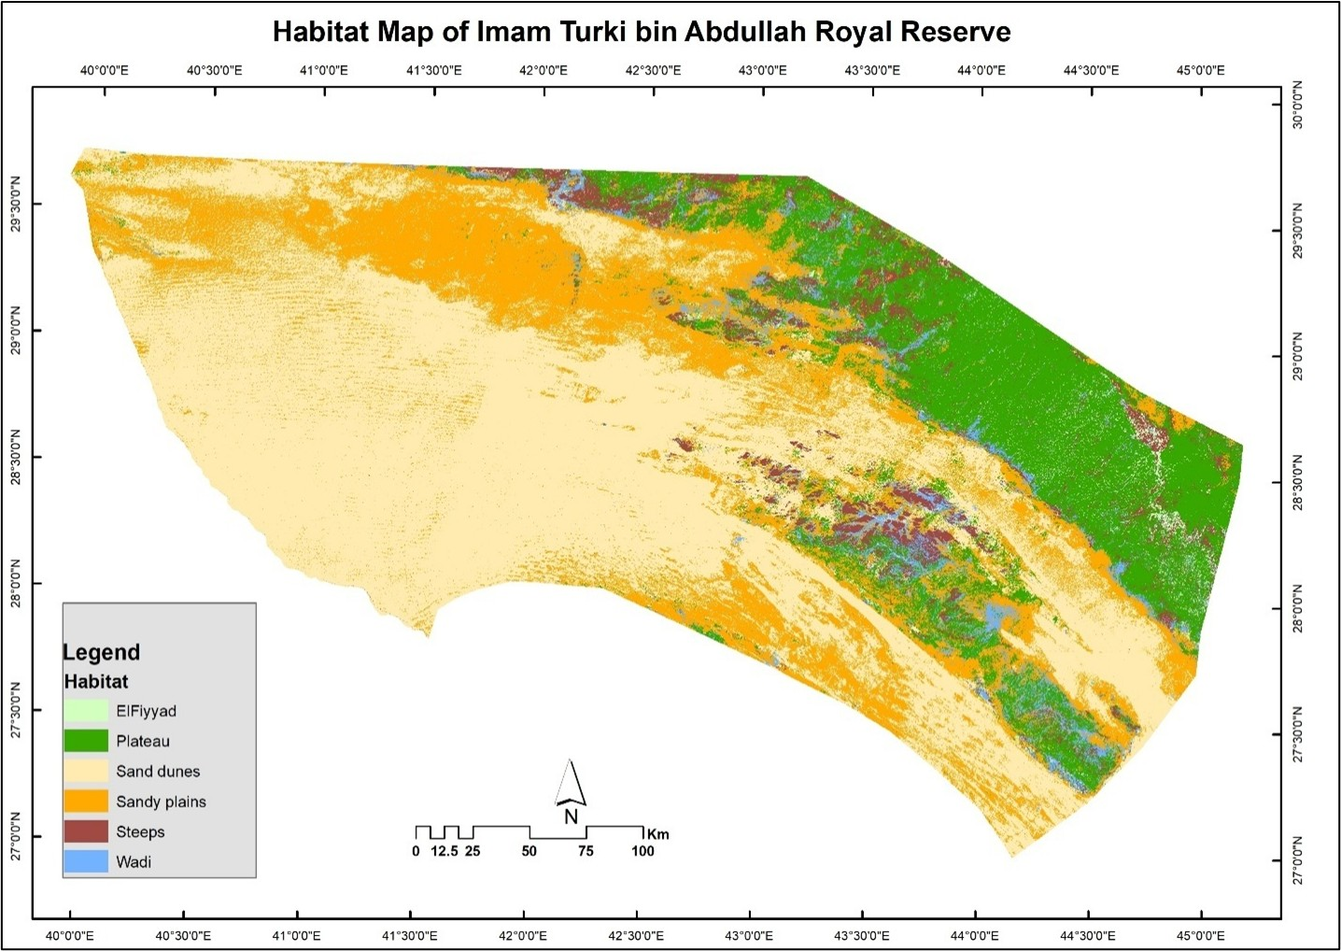

Botanical assessments have documented 235 plant species across 47 families, structured into 16 vegetation communities. Faunal diversity within ITBA is equally rich, with 10 large mammal species, 30 reptile species, over 40,000 invertebrates, and 184 bird species, including nine species which are globally threatened. Situated along the Afro-Eurasian flyway, the reserve functions as a critical stopover for migratory birds, including the vulnerable Asian houbara bustard.

The Reserve adopts a community-based approach for ecosystem restoration through developing sustainable rangeland management programs and active reforestation initiatives, including the plantation of more than 775,000 native trees across. In parallel a reintroduction of key species such as the Arabian oryx, Sand gazelle, Asian houbara, and red-necked ostrich have been implemented. At the Reserve core lies the Al-Taysiyah zone, a fully protected zone that serves as a scientific reference for the success of ecological restoration, demonstrating the effectiveness of conservation measures.

Satellite monitoring between 2020 and 2025 has revealed notable improvements in vegetation density and distribution that jumped from 3.6 % to 9.4% due to the implementation of the restoration program. These ecological gains reflect the effectiveness of protection policies, and grazing regulation. Beyond biodiversity, ITBA integrates conservation with community well-being through seasonal grazing programmes that benefit more than 12,000 herders, balancing ecological resilience with socio-economic needs. This integration highlights ITBA’s role as a living model of how ecosystem restoration and community engagement can support both environmental sustainability and cultural traditions in arid environments.

The distribution of vegetation cover in 2025 further illustrates the ecological variability of ITBA’s landscapes. The reserve recorded a total green cover of 8,638 km² (9.44% of its total area), with significant variation across habitats. Wadis (17.91%) and El-Fiyyad depressions (27.63%) showed the highest proportional vegetation cover due to their ability to retain water and sediments, making them highly productive ecosystems. In contrast, the vast sandy plains (10.41%) and sand dunes (9.24%) supported moderate cover, while the plateaus (5.63%) recorded the lowest levels, reflecting shallow soils and limited water retention. Steppes (9.86%) provided transitional landscapes that contribute to ecological connectivity. Importantly, the Al-Taysiyah core zone recorded 23.34% vegetation cover, significantly higher than the reserve-wide average, underscoring the impact of strict protection and restoration efforts. These habitat-specific patterns emphasize the importance of ecological heterogeneity in sustaining rangeland productivity, biodiversity recovery, and long-term ecosystem resilience.

**Impacts: Facts and Numbers**

* Vegetation recovery: Vegetation cover in the northern protected sector expanded from 63.68 km² in 2020 to 723.87 km² in 2025 (+1037%). Reserve-wide vegetation cover reached 8,638 km² (9.44%) in 2025, marking an increase from 2024 levels.
* Habitat diversity: The Al-Taysiyah core zone encompasses 1,526 km² of dunes, 1,067 km² of sandy plains, 772 km² of plateaus, 835 km² of steppes, 542 km² of wadis, and 38 km² of flood plains.
* Plant diversity: A total of 235 species has been recorded, including 133 annuals and 102 perennials, across 47 families and 16 vegetation communities.
* Restoration efforts: More than 775,400 trees.
* Wildlife breeding success: Sand gazelle (110), Arabian oryx (66), rock hyrax (21), Arabian hare (25), red-necked ostrich (28), Arabian gazelle (2), Asian houbara (16).
* Reintroduction of kye species: A total of 460 wild animals including, Sand gazelle (116), Arabian oryx (77), rock hyrax (8), Arabian hare (20), Asian houbara (236), red-necked ostrich (3).
* Rangeland condition: The rangeland conditions improved from high severity to the following categories: Severely degraded (2,434 km²), degraded (6,381 km²), medium (922 km²), and good (1,190 km²).
* Community benefits: Seasonal grazing supports over 12,000 herders, reducing costs by 160 SAR per camel/month, equivalent to 3.52 million SAR monthly and 17.6 million SAR per 5-month grazing season.

