Detailed explanation and working procedure of each mechanism of mattress-making machine (Absorbent core)
Detailed Working Mechanism
Shredding - The paper made of banana fiber is shredded by using a shredding machine into 8*8 mm uniform pieces.
Feeding – Uniformly shredded paper is manually fed onto the hopper which consists of Archimedes screw and agitator. The shredded paper gets filled in the pitch of the screw completely and screw moves to feed the pieces to mouth of pulverize with constant volume. Here, the agitator plays important role to mix the pieces of paper and also prevent clogging.
Pulverizing – Constant volume of pieces of paper is pulverized by rotating blades of the pulverizer. The pulverized fluff passes through the mesh below the blades which plays vital role to ensures fineness and proper uniform distribution of fluff between conveyer belt which is confined in width.
Sheet formation - The fluff moves forward with the belt to the pressing unit. The pressing unit consists of six-roller arrangement i.e. three at top and three below. The fluff passes through middle and get pressed to form sheet. Desired compression of sheet can be achieved by adjusting gap between rollers.
Air Cutting- The formed sheet moves to cutting section by conveyer belt. The cutting section incorporates arrangement of nozzles, pipes, universal timers, pneumatic valves, pneumatic cylinder, air compressor, limit switch and dies. The cutting takes place in the moving belt which has uniform sheet formed before. When cutting section is pressing the sheet, it moves with the same speed of conveyer belt with the help of wheels. With the help of compressed air coming out of nozzle air blow away the fluff which is not compressed by die.
Suction – As the cutting system is completely closed from bottom to prevent the fluff from scattering which facilitate the suction system to suck all the excessive fluff.
Suction system contains flexible pipe, one end connected to cutting unit and another end connected to the centrifugal pump inlet. The centrifugal action of pump created pressure difference between inlet of centrifugal pump and end connected to cutting unit. The resulting pressure facilitates suction of extra fluff during cutting process.

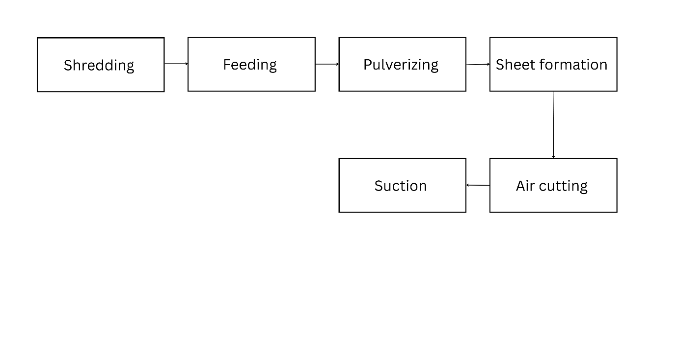
Operating Procedure:
The banana fiber paper production process begins with a pre-start inspection where the machine is checked for debris, power/air supply are verified, and blades/rollers are cleaned. Operators then feed small batches of clean, dry banana fibers into the shredder. The processing stage involves shredding the fibers, transferring them to a hopper (with agitator running), pulverizing through a fine mesh, forming sheets on a conveyor belt, and pressing between six rollers. For cutting, compressed air nozzles precisely shape three pads at a time (12 pads per minute total) while a suction system collects excess fibers for recycling. The final stage includes quality inspection of pads before packaging, followed by machine shutdown and thorough cleaning. Throughout operation, safety measures like wearing gloves/goggles and avoiding loose clothing near moving parts are essential. The complete cycle takes approximately 15 minutes per batch with a consistent output of 12 pads per minute.
Sequence of operations
Pulverizer Runs → Belt system Starts → Screw System Operates →cutting system and suction system
This order of operation is crucial for uniform fibre distribution and to prevent jamming of fibre.
For Circuit diagram of whole machine, check titled PDF “Electrical connection diagram of cutting system”
Cutting System Working Mechanism:
Although we refer to it as a "cutting system," the mechanism does not actually cut the fluff. Instead, it blows away excess fiber that is not pressed by the dies. These dies are arranged inside a closed cubic box. There are three pressing die units shaped and sized according to the required absorbent core for the pad. The dies are placed with small gaps in between, allowing a pipe carrying compressed air to move back and forth to blow away the fluff between the dies.
When the machine is started in sequence, it takes a few minutes to form a uniform sheet. Only after that can the cutting system be activated to obtain the absorbent cores from the mattress sheet.
When the machine is not running, the cutting block rests on the conveyor belt. When the machine starts, the compressor must be switched on to supply air pressure, which keeps the cutting system in Position 0, slightly above the moving conveyor belt.
Flexible air pipes are used to connect the solenoid valve, pneumatic cylinder, and air compressor. Various fittings are used in the system, such as flow controllers, tee connectors, unions, diameter reducers, threaded fittings, and push-to-connect fittings.
Once a uniform sheet begins to form, the suction system and timer box are powered on. The suction motor starts running, but the cutting system does not begin yet. First, the cutting system must be manually moved to the starting position (Position 0) by gently pushing it with your hand-it moves easily thanks to the wheels connected to it.
Next, by turning the switch on from the timer box, the cutting system starts operating. The cutting block moves from Position 0 to Position 1. This motion is controlled by a timer that activates the solenoid valve. The pneumatic cylinder pushes the cutting block down to press the mattress sheet coming from the sheet-forming machine.
When the cutting block presses the sheet and conveyor, a limit switch is triggered. This sends power to the second timer, which energizes another solenoid valve. Compressed air is then released through the pipe nozzle, initiating a to-and-fro motion. A cross-pipe arrangement blows away the fluff around the pressing dies.
This air-blowing action runs for 8 seconds in 4 loops. During this time, the cutting system moves from Position 1 to Position 2 at the same speed as the conveyor belt, pressing the conveyor during the process.
This position is crucial-the suction system removes all the fluff waste during this time. The effectiveness of the cutting and its sharpness depend on air pressure in the pipes.
After 8 seconds, the pipe motion stops, and the cutting block moves up to Position 3 and holds for 1 second. Then the entire cutting system returns to its initial position (Position 0), where it holds for 1.5 seconds before starting another cycle. Each cycle takes 14 seconds and produces 3 absorbent cores, resulting in 12 absorbent cores per minute.
In this way, the cutting system operates automatically. At the end of the operation, the timer box should be switched off first before shutting down the other machines.
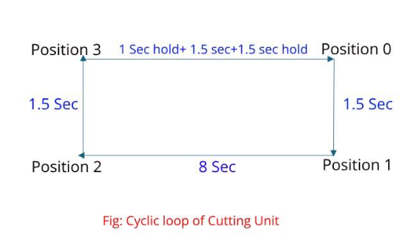

Step-by-Step Mattress Machine Running Protocol:
- Turn on the compressor and supply air to the cutting system.
- Ensure the machine is clean and free from any tools or extra items before starting.
- Provide power to the entire machine and switch it on in the correct sequential order as mentioned earlier.
- Feed at least the minimum amount of shredded paper into the hopper and wait until a uniform sheet is formed by the sheet-forming unit.
- Once a uniform sheet is achieved, supply power to the suction system and the timer box of the cutting system.
- After completing production, follow the machine shutdown sequence and turn off the air supply from the compressor.

