**In this document, you will get the Electrical connection of the Whole Mattress Machine and pneumatically actuated cutting solutions**

*Full machine connection diagram:*

This machine requires both three-phase and single-phase power supply. The single-phase supply is used for the fluff suction system and the sheeting cutting system to actuate the pneumatic cylinder, while the three-phase supply powers the other components.  
A three-phase motor is used to drive the system, as it is more energy-efficient than a single-phase motor. A speed reducer gearbox with a 30:1 ratio is used for speed reduction, and a Variable Frequency Drive (VFD) is connected for more precise speed control.

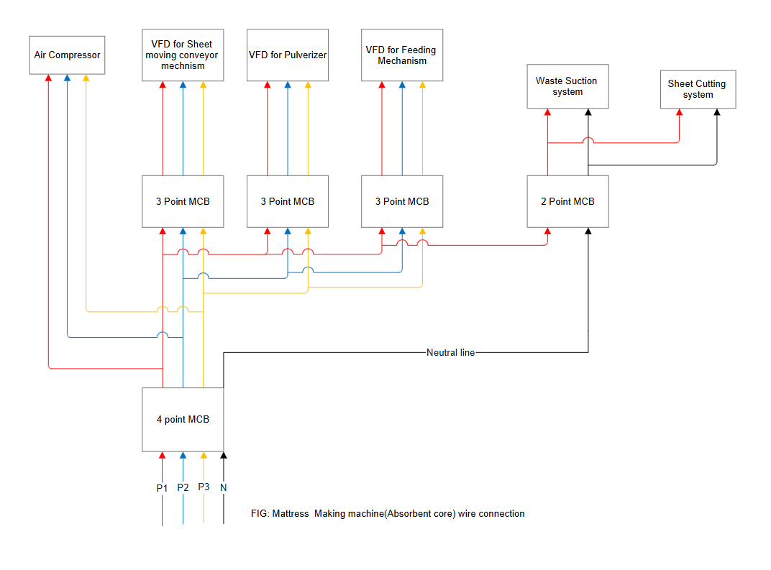

*Pneumatically actuated cutting solutions connection diagram:*

This cutting system is a bit complex. A universal sequential timer is used to actuate the solenoid valves, which are connected to pneumatic cylinders. These cylinders control the motion of the piston rods, which are further linked to a pipe arrangement surrounding the pressing die. The pipe contains nozzles through which compressed air is released to blow away any excess fluff that has not been pressed by the die.

**Why is a Universal Timer Needed?**

The cutting system operates automatically. When voltage is supplied to the system, the solenoid valves are energized and shift from their initial position. Position 0 of the cutting system is defined based on the connection point of the air pipe to the pneumatic cylinder. The timer is used to control the directional change of the pneumatic cylinders, enabling looping of the entire cutting cycle for a set time interval.

Two sequential timers are used to control the motion of five pneumatic cylinders and five solenoid valves. The timers can be programmed similarly, depending on the system’s overall requirements. Below, you can see a circuit diagram showing the connection between the timers and the pneumatic cylinders.

We have divided the pneumatic system into four parts:

1. **Main Solenoid**: Controls the up-and-down motion of the entire cutting system for a specified time.
2. **Nozzle Solenoid**: Activates to release air from the nozzle when the limit switch is triggered, for a set duration.
3. **Pneumatic Solenoid**: Controls the to-and-fro motion of the pipe carrying compressed air.
4. **Down Pneumatic**: Returns the cutting system to its initial position at the end of each loop, allowing the cycle to restart.

Fig: Circuit diagram of the solenoid valve with sequential timer

FIG: Sequential timer user interface for programming a relay.

**Technical specifications: Timer used**

|  |  |
| --- | --- |
| **Category** | **Specification** |
| **Case Size** | 72 x 72 x 45 |
| **Panel Hole Size** | 92 x 92 |
| **Range Limit** | 9.999 / 99.99 / 999.9 / 9999 |
| **Unit** | Sec. / Min. / Hz |
| **Mode** | On Delay / Preset / Cyclic / Laundry |
| **Set Point** | 2 Set Point |
| **Output** | 2 Relay (1 C/O) |
| **Description** | 4 Digit Dual Display |
| **Display** | 3 Digit Single Display |
| **Keyboard** | Feather Touch Key Board |
| **Indication** | Indication For Relay Status |
| **Mounting** | Panel Mounting with Side Clamp |
| **Power Supply** | 90 - 270 VAC, 50 Hz |