**WHO SAID ONLY PROJECTS MATTER? GOMEZA COMMUNITY IN SELF-DRIVE TO CONSERVE THE PROTECTED AREAS**

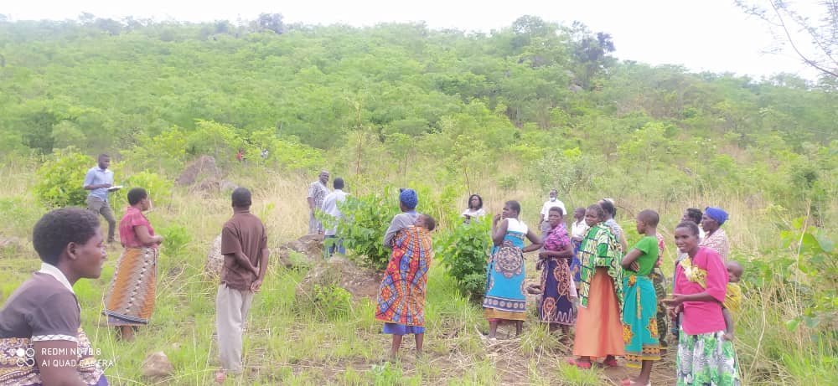

*From bare to cover, Gomeza community members appreciating the restored forest area*. Photo: Donnex Mtambo

**Summary**

1. **Malawi Championship-Forest Management**

The government of Malawi has a Strategic Plan to restore 4.5 million ha of degraded forest and agriculture land by 2030. There have been efforts to achieve this through projects and empowerment of local communities around protected forest reserves to take proactive roles in forest conservation. Nthceu District is one of the most populated and face high deforestation rates in the country. A number of projects were implemented to conserve degraded forests and agricultural land. However, the success of these projects have remained debatable. Some silent approaches of community empowerment to take active role in conserving protected forest reserves seem to bear fruits. Gomeza Community (1,026 individuals 42% male, 58% female) noted the catastrophic degradation of Mvai Forest Reserve and decided to embark on restoration programme by itself. It selected a portion of 15 ha and named it Gomeza forest. The community put in place governance and resource use measures. It has by-laws to restrict deforestation in Gomeza Forest. It has workscedule for volunteers to make patrols. Since 2014 the community has restored 15 ha of the 5000 ha Mvai Forest Reserve. Now Gomeza Forest is inhabited by wildlife species such as hyenas, rabbits, snakes and rats. The common snakes include Black mamba and cobra. Hyenas and rabbits were considered extinct in the area before 2014 but have become common animals in this restored forest.

**Challenges**

Like most countries in Sub-Saharan Africa, Malawi faces multidimensional challenges from economic to environmental. Deforestation rate is pegged at 2.8% and most protected forest reserves are highly encroached by surrounding communities. Charcoal making and wood harvesting dominate. Attempts to address these problems have focused on development of projects by either government or Non-governmental organisations and force these projects on the communities. Most solutions have focused on assumptions that communities are destructive to protected forest reserves. Less attention has been paid to communities that use **self-drive** to conserve protected forest reserves. It is against this background that Ntcheu District Council in collaboration with partners assessed the strides taken by some communities on the restoration of Mvai Protected Forest Reserve in Ntcheu District, Central Malawi. The focus was on the role Gomeza Community plays in restoring 15 ha of the reserve.

**Beneficiaries**

Human in the district country

Trees in the district

Wildlife in the reserve

Human population globally through carbon sequestration

**Restoration approach and relevant activities (Background)**

Gomeza Community manages Gomeza Forest which falls within the Protected Mvai Forest Reserve. The community operates in Group Village Head Gomeza, Traditional Authority Kwataine, Ntcheu district, Central Malawi. The community comprises seven villages namely Mkwela, Gomeza, Chindipha, Pemba, Chapita and Njenje from 420 households. The initiative started in 2014 by the community itself. It then got support from Malawi Social Action Fund (MASAF 4). The community is currently benefiting from Malawi Resilience Disaster Risk Reduction Project (MRDRRP) and the Alliance for the Restoration of Forest Large Scales in Africa (AREECA). The forest is 15 ha in size. The community has a lead committee comprising 12 female and 8 male members. Major activities revolve around fire break maintenance, forest patrols, screefing, firefighting and enforcement of bylaws. The developmental objectives for restoration are:

1. To rehabilitate and protect the catchment area
2. To reduce erosion to prevent siltation of Mpira Dam
3. To recharge ground water

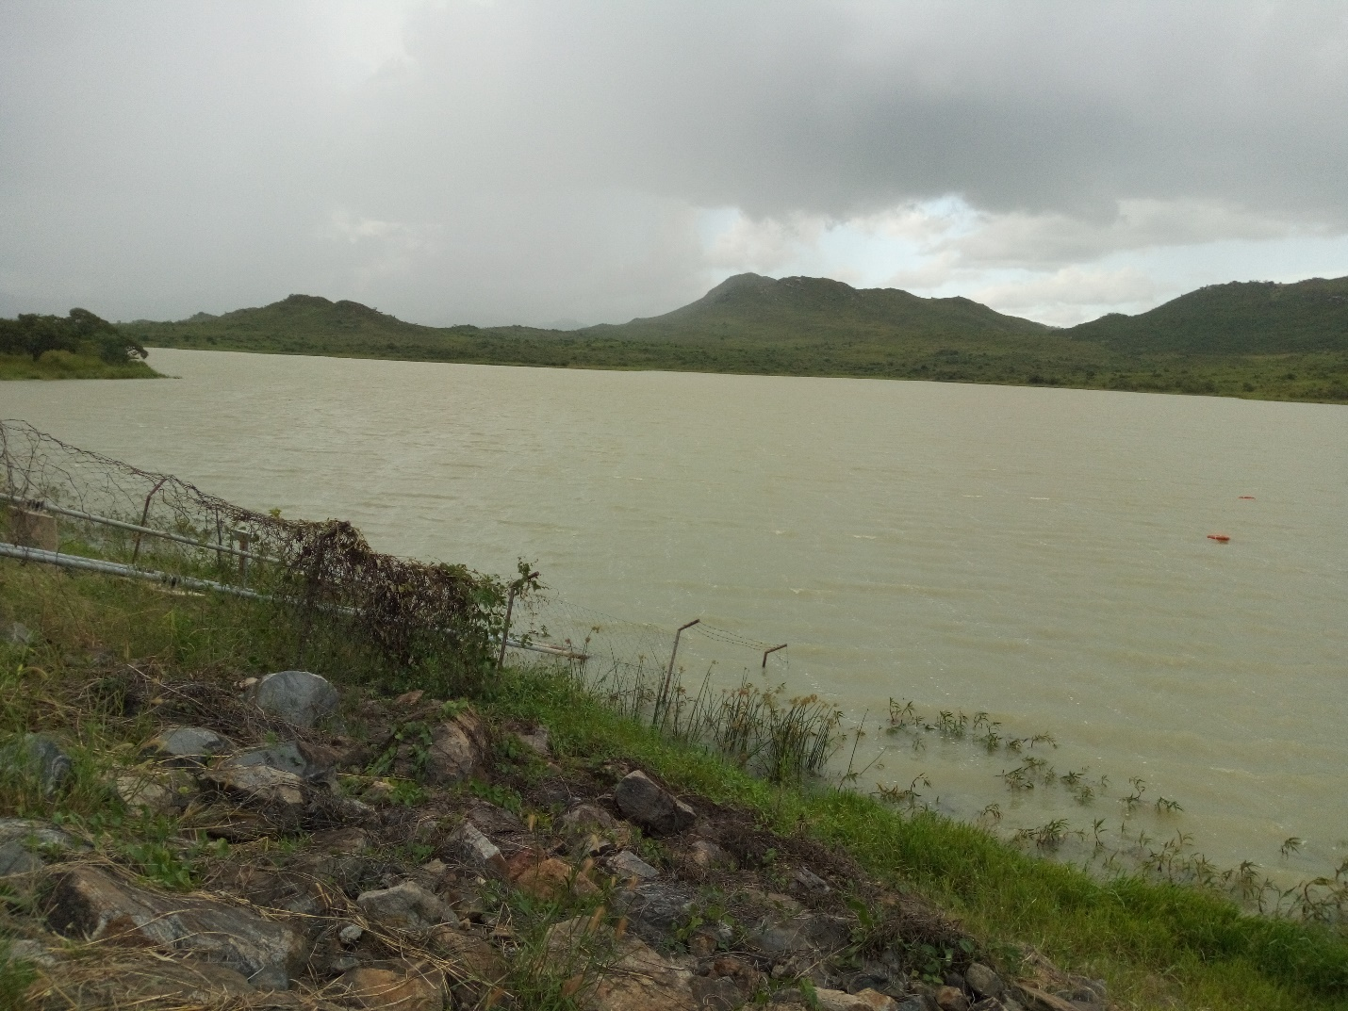

*Mpira Dam, a target of conservation by Gomeza Community. Photo Harrington Nyirenda*

**Community-involvement**

*Planning*: Community members noted that there was high environmental degradation in the catchment area. They mobilized themselves to brainstorm the actions to be taken so that the area was restored. Every member was given an opportunity to suggest the possible solutions. They unanimously agreed to manage the Gomeza forest (part of Mvai Protected Forest Reserve).

*Implementation*: The self-initiated restoration at Gomeza attracted institutions such as MASAF 4 and MRDRRP to provide incentives such as nursery inputs (tree seeds, watering cans, polythene tubes, wheel burrow and shovels) and working tools (slashers, sacks). Furthermore, MRDRRP and AREECA supported with capacity building on nursery establishment and natural regeneration. To reduce soil erosion in bare areas, community members did enrichment tree planting. They reclaimed land in gullies through vetiver grass hedgerow planting. They have approved working by-laws which are enforced by the community members themselves. For example, anyone found cutting a tree without permission pays MK10,000.00 (USD10) per tree. The community conducts regular patrols to ensure no one cuts the trees. This is achieved through community volunteers who work on shifts on these patrols. Apart from the daily regular patrols, they also carry out fire break maintenance and early controlled burning every year to reduce fire incidences. Community holds regular meetings to review their work progress based on their work plan.

*Decision making*: The community has provision for election of office bearers and hold elections as stipulated in their constitution. They formulate work plans on their own where everyone in the community is given an opportunity to suggest the activities to be undertaken. This promotes ownership of the interventions. The community decides their work schedule and take full control on the implementation. Resource use is under full control of the community.



*From bare to cover, Gomeza community members appreciating the restored forest area*. Photo: Donnex Mtambo

**Impact of the solution**

*Improved land management*: The area which was previously bare, has been fully rehabilitated. The whole area is covered with indigenous trees. This has resulted in reduced soil erosion. Gullies have been reclaimed which have reduced runoffs and increased ground- recharge. The reduced runoff have consequently reduced siltation at Mpira dam.

*Contribution to nature conservation*: The restored forest has provided conducive environment for the previously lost wildlife. The forest is inhabited by wildlife species such as hyenas, rabbits, snakes and rats. The common snakes include Black mamba and cobra. Hyenas and rabbits were considered extinct in the area before 2014 but have become common animals in this restored forest. Night patrols are greeted with sounds of rolling hyenas as days are drenched with varieties of singing birds. Contrary, to the dominance of gullies before restoration, the forest surface is currently carpeted with leaf thickets and burrowing animals, evidence of increased soil activities and habitable environment. There is increased biodiversity in the forest. The forest has witnessed increased bee occurrence in the area. These bees have colonized natural tree hollows. This phenomenon was never the case when the area was bare.

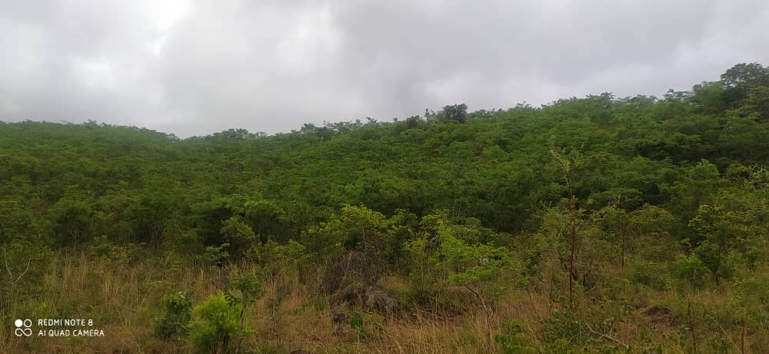

*Part of Gomeza Forest under Mvai Protected Forest Reserve, Ntcheu District, Central Malawi*

*Socio-economic benefits*: Of paramount to notice is the availability of wild fruits in the forest. These fruits are collected by the communities for food and selling. Among the dominant fruits area, *Azanza garkiana*, *Flocourtia indica,* *Uapaka kirkiana*, *Anona senegalensis*. The managed forest has become a destination for nature appreciation among the surrounding community members and those from distant places. The area is visited by communities and institution from other districts in Malawi to learn and appreciate the restoration of the protected forest reserve by communities. The forest shares boarders with Gomeza Primary School. The forest is a model for learning as it acts as field laboratory for *Forest* Subject in the primary school curriculum. One of the teachers at the school, Lucia Likagwa observes, ‘*We have a laboratory without walls where we always take our Standard 6 pupils for learning especially when we deliver a topic on* *Forests*. *The topic focuses on meaning of forest*, *importance of forest*, *destruction and ways of conserving forests, creating a sense of ownership by community around the forests*.’ The school got motivated by the community and it decided to establish its orchard with support from AREECA project. Currently, the community requested for start-up inputs for bee keeping (honey production) as a vehicle for forest management. The community has been nominated by AREECA project to venture into the desired enterprise for income generation. This enterprise will lead to increased management of the reserve.

*Information on beneficiaries*: Gomeza community comprises 420 households, with an estimated human population of 1,026. Of this population, 42% are male while 58% females. The youth represents 55%.

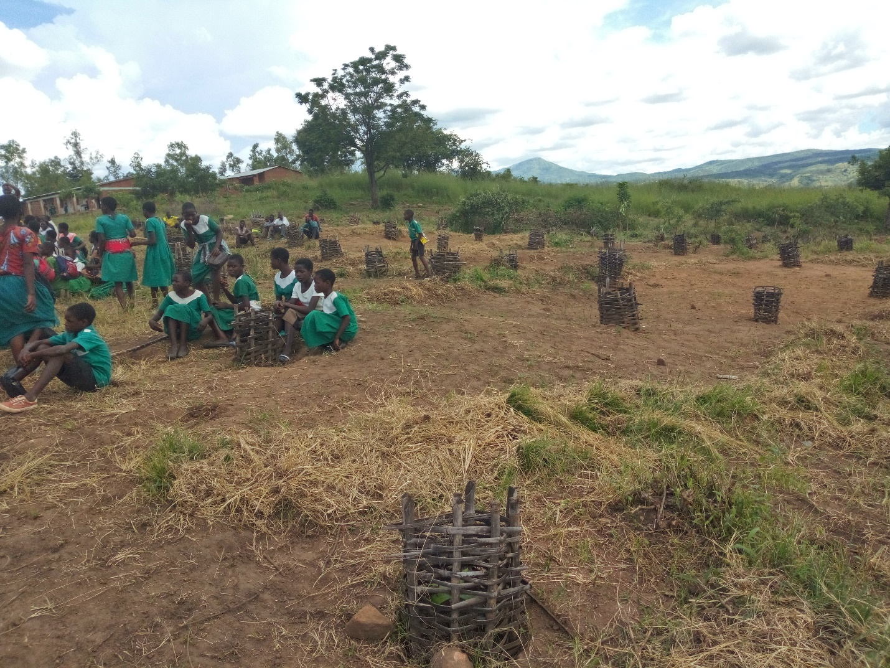

*Part of an orchard at Gomeza Primary School has established with support from AREECA after appreciating the efforts by Gomeza community. Photo: Harrington Nyirenda*

**Innovation and Sustainability of the approach**

The scenario at Gomeza community is unlike many communities where restoration initiatives start with projects. Project institutions mobilise communities to carry out restoration activities. At Gomeza, communities mobilized themselves after noting loss of natural forests in the protected reserve. Project and institution had to follow the footsteps of Gomeza community to motivate and support them. This self-drive is unique and provides hope of sustainability for the initiative. Unlike in other forest reserves in Malawi where government spend millions of financial resources to mobilise Defence Forces and Forests Guards to protect forest reserves, at Gomeza patrols are done by community volunteers and there has been no serious cases of catastrophic proportions unlike where Defence Forces manage the forests. This forms the base of continued and rare commitment among Gomeza community. The existence of working by-laws enforced by the community itself is evidence enough of an organized and focused community.