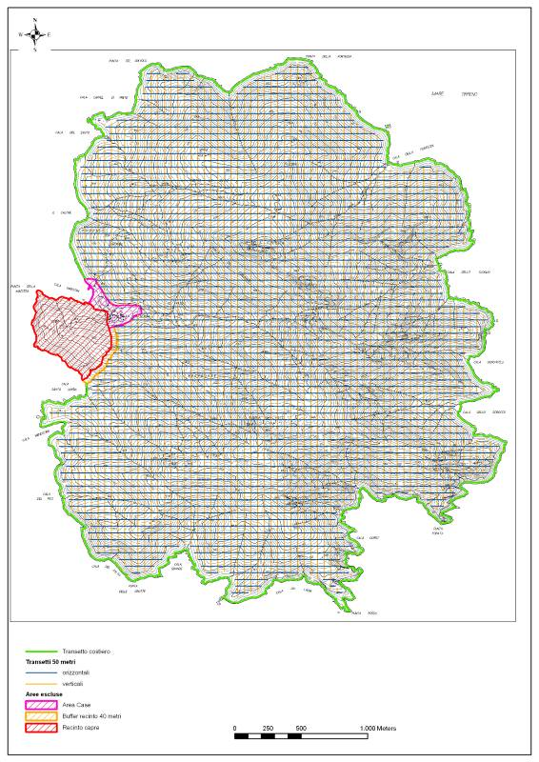
Eradication Plan: aerial transects and bait station zone.

