TREE GANDA ACADEMY (TUA)
Revitalizing the Nature of Uganda

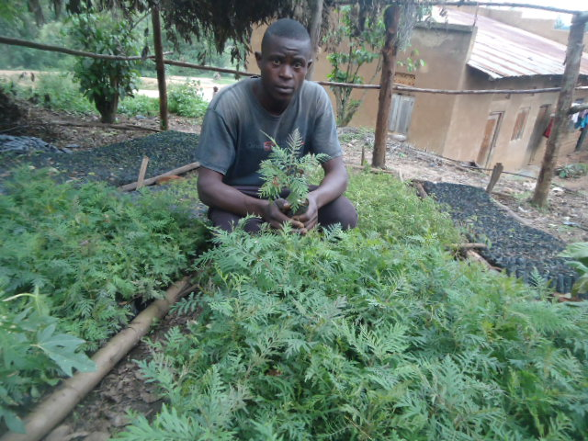

UNDERSTANDING OF CARBON ANDTHE ROLE OF TREE PLANTING IN CARBON REDUCTION & CLIMATE CHANGE MITIGATION

UNDERSTANDING OF CARBON
What is Black Carbon?
Black carbon is the sooty black material emitted from gas and diesel engines, coal-fired power plants, and other sources that burn fossil fuel. It comprises a significant portion of particulate matter or PM, which is an air pollutant.
Carbon Black (CB) is a specific type of elemental carbon in the form of colloidal particles that is generated or produced through incomplete combustion processes or the thermal decomposition of gaseous or liquid hydrocarbons under controlled conditions. It occurs as a black fine dusty powder that must be differentiated from the undefined byproducts soot and diesel exhaust particulates generated during coal or hydrocarbon combustion. Carbon black consists of more than 96 percent of amorphous carbon and of small quantities of oxygen, hydrogen, nitrogen, and sulfur. Most of these elements are concentrated on the surface.

Black carbon is a global environmental problem that has negative implications for both human health and our climate. Inhalation of black carbon is associated with health problems including respiratory and cardiovascular disease, cancer, and even birth defects. Black carbon also contributes to climate change causing changes in patterns of rain and clouds.
As black carbon deposits in the Arctic, the particles cover the snow and ice, decreasing the Earth’s ability to reflect the warming rays of the sun, while absorbing heat and hastening melt.
Black carbon research is being conducted in many areas to improve understanding of this tiny carbon particle:

How is black carbon produced?
It is formed through the incomplete combustion of fossil fuels, biofuel, and biomass, and is emitted in both anthropogenic and naturally occurring soot. Black carbon causes human morbidity and premature mortality. In climatology, black carbon is a climate forcing agent.
BC is produced both naturally and by human activities as a result of the incomplete combustion of fossil fuels, biofuels, and biomass. Primary sources include emissions from diesel engines, cook stoves, wood burning and forest fires.
What effect will black carbon deposits have on glacial ice?
Snow covered regions are the most vulnerable to the warming effects of black carbon, and any particles reaching them are of concern if they are darker than snow, because they can reduce reflectivity and speed melting.

What is a brown carbon?
In chemistry, brown carbon (C_{brown}/BrC) is brown smoke released by the combustion of organic matter. ... Black carbon is primarily released by high-temperature combustion and brown carbon is emitted mainly by biomass combustion. These two are the two most important light absorbing substances in the atmosphere.

What does Black carbon do to the human body?
Black carbon is a major contributor to the fine particle (known as particulate matterPM2.5) burden in the air. It is small enough to be easily inhaled into the lungs and has been associated with adverse health effects.
Black carbon, a component of particulate matter, is especially dangerous to human health because of its tiny size. But black carbon not only has impacts on human health, it also affects visibility, harms ecosystems, reduces agricultural productivity and exacerbates global warming.
Peat-burning wildfires release enormous amounts of PM, including black carbon, which has been linked to increased risk of heart failure and respiratory hospital visits.

What is the use of carbon black?
More than 90 percent of all carbon black is used as filler in the rubber industry, mainly in tires and technical rubber products such as conveyor belts, flexible tubes, and sealing profiles. Moreover, carbon black is used as black pigment in printing inks, India inks, paints and varnishes, for dyeing and for UV protection of plastics as well as in special products such as mascara, flower soil, decor paper, and fibers. As conductive carbon black, it is used in the electrical industry to manufacture electrodes and carbon brushes.
In plastics, paints, and inks carbon black is used as a color pigment. However, carbon black is widely used as a model compound for diesel soot for diesel oxidation experiments.

What is the main source of black carbon aerosols?
Black Carbon Aerosol from Fossil Fuels. Black carbon (BC) is a primary aerosol emitted directly at the source from incomplete combustion processes such as fossil fuel and biomass burning and therefore much atmospheric BC is of anthropogenic origin.Biomass is an industry term for getting energy by burning wood, and other organic matter. Burning biomass releases carbon emissions.
How do aerosols affect the climate?
Aerosols and Clouds (Indirect Effects) whereasaerosols can influence climate by scattering light and changing Earth's reflectivity, they can also alter the climate via clouds. On a global scale, these aerosol “indirect effects” typically work in opposition to greenhouse gases and cause cooling

Aerosols and Clouds (Indirect Effects)
Whereas aerosols can influence climate by scattering light and changing Earth’s reflectivity, they can also alter the climate via clouds. On a global scale, these aerosol “indirect effects” typically work in opposition to greenhouse gases and cause cooling. While greenhouse gases disperse widely and have a fairly consistent impact from region to region, aerosol effects are less consistent, partly because of how the particles affect clouds.
Most elementary school students learn that clouds form when enough water vapor condenses. That’s true, but aerosols play a critical role in the process. In fact, most clouds owe their existence to aerosols that serve as the tiny “seeds,” called cloud condensation nuclei.
Natural aerosols—often sulfates, sea salt or ammonium salts—are the most common condensation nuclei in pristine environments. Polluted air, in contrast, usually contains much higher concentrations of water-soluble particles, which means pollution-rich clouds tend to have more numerous, but smaller, droplets. The small droplets make polluted clouds look brighter than they would otherwise be. Just as many bits of crushed ice give light more surfaces to reflect off—appearing brighter than a solid cube of ice—if the water in a cloud is divided into a larger number of smaller droplets, it will scatter more light and become more reflective.
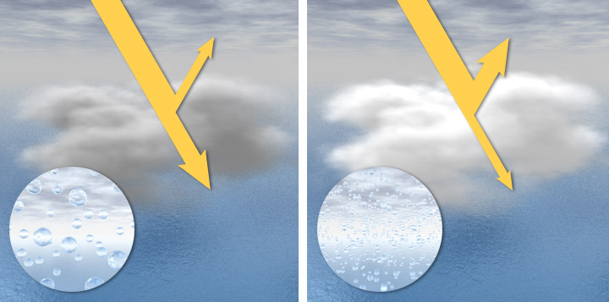
Clouds in clean air are composed of a relatively small number of large droplets (left). As a consequence, the clouds are somewhat dark and translucent. In air with high concentrations of aerosols, water can easily condense on the particles, creating a large number of small droplets (right). These clouds are dense, very reflective, and bright white. This influence of aerosols on clouds is called the “indirect effect,” and is a large source of uncertainty in projections of climate change. (NASA image by Robert Simmon.)
Brighter clouds, in turn, block sunlight from reaching Earth’s surface, shading the planet and producing net cooling. This cloud brightening effect—called the “cloud albedo effect”—may have a big impact on the climate, though only in recent years has it been possible to start quantifying the effect.
This impact of aerosols is clearly visible in ship tracks, bright streaks in marine clouds that look like airplane contrails. In the absence of ships, sea salt particles and the natural sulfates produced by phytoplankton seed most marine clouds. However, the exhaust from ship smokestacks make trails of sulfates and other aerosols that form long, bright clouds.
Overall, clouds are thought to cool Earth’s surface by shading about 60 percent of the planet at any one time and by increasing the reflectivity of the atmosphere. Given that, just a 5 percent increase in cloud reflectivity could compensate for the entire increase in greenhouse gases from the modern industrial era in the global average. Likewise, long-term decreases in cloudiness could have major impacts.
However, aerosols are distributed around the planet differently than greenhouse gases, so the effects do not simply cancel each other. Parsing out how clouds—as well as feedback cycles involving clouds—affect regional climate systems remains a high priority for climatologists.
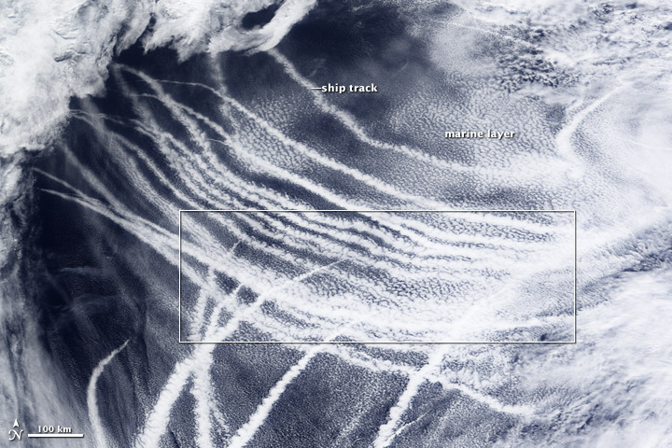
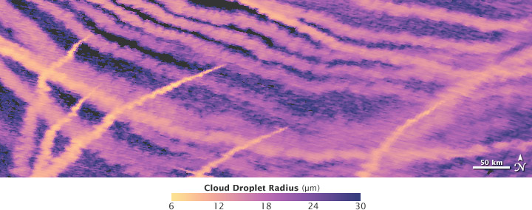

The effect of aerosols on clouds is clearly visible in ship tracks—the dense, bright marine clouds formed by the exhaust of passing ships. This natural-color image shows the bright white clouds (top) and a map of cloud droplet radius (bottom). Where ship exhaust mixed with the cloud layer, droplets became much smaller. (NASA image by Jesse Allen and Robert Simmon, based on data from MODIS.)
Aerosols also have complex effects on clouds and precipitation. Broadly speaking, aerosols are thought to suppress precipitation because the particles decrease the size of water droplets in clouds. However, under some environmental conditions, aerosols can lead to taller clouds that are more likely to produce lightning and strong downpours. In a few places, meteorologists have even detected a cycle in which the frequency of thunderstorms is connected to mid-week peaks in aerosol emissions.
Aerosol type plays an important role in determining how aerosols affect clouds. Whereas reflective aerosols tend to brighten clouds and make them last longer, the black carbon from soot can have the opposite effect. Studies of pollution over the Indian Ocean and biomass burning smoke in the Amazon have shown that the black carbon warms the surrounding atmosphere and can cause cloud droplets to evaporate. This process, called the “semi-direct effect,” turns clouds into a smoky haze that suppresses precipitation.
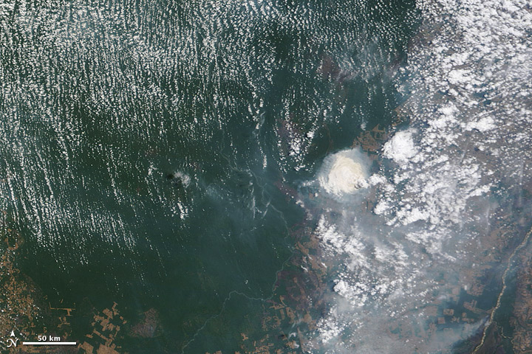
Interactions between smoke and clouds are complex. In some cases, smoke and other aerosols help cloud formation. In others, smoke suppresses clouds. Both effects are apparent in this natural-color satellite image of the Brazilian Amazon, acquired on August 31, 2010. (NASA image by Jeff Schmaltz, MODIS Rapid Response.)
Current estimates suggest the cooling driven by aerosol indirect effects is less than half as much as the warming caused by greenhouse gases when averaged over the globe. But these indirect effects are highly uncertain and vary considerably in space and time. Therefore, on smaller space and time scales, the climate effects of aerosols can be significant.
The details of aerosol indirect effects are only partially understood, as most instruments cannot measure aerosols within clouds. Climatologists consider the role of clouds to be the largest single uncertainty in climate prediction. Less than a third of the models participating in the Fourth Intergovernmental Panel on Climate Change (IPCC) included indirect aerosol effects, even in a very limited way, and those considered only sulfate aerosols.

Health effects of black carbon
Reducing people’s exposure to PM_{2.5} containing black carbon should lead to a reduction in the health effects associated with PM.
Exposure to black carbon is linked to health impacts such as cardiopulmonary morbidity and mortality, and reducing people’s exposure to particles containing black carbon will therefore also reduce such adverse health impacts, according to a recent report published by the World Health Organization (WHO).
Prepared for the Task Force on Health Aspects of Air Pollution under the Convention on Long-range Trans boundary Air Pollution, the report was produced as input to the revision of the Convention’s Gothenburg Protocol (see article on front page), and it presents the results of a systematic review of evidence of the health effects of black carbon in ambient air.
The report concludes that toxicological studies suggest that black carbon may operate as a universal carrier of a wide variety of chemicals of varying toxicity to the human body, and that reducing people’s exposure to particulate matter containing black carbon should reduce its effects on their health.
Black carbon (BC) is said to be an operationally defined term, which describes carbon as measured by light absorption, and as such it is not the same as elemental carbon (EC), which is usually monitored with thermal-optical methods. As yet, there are no generally accepted standard methods to measure BC or EC in atmospheric aerosol, so there is a need for standardization.

Black carbon can seriously damage
your health. Photo: Esther Simpson

The main sources of black carbon emissions are diesel-driven combustion engines (in road vehicles, non-road mobile machinery and ships), residential burning of wood and coal, power stations using heavy oil or coal, field burning of agricultural wastes, as well as forest and vegetation fires.
Due to the location of these sources, the spatial variation of BC in ambient air is greater than that of PM2.5, but in general ambient measurements or model estimates of BC are said to reflect personal exposures reasonably well and with similar precision as for PM2.5.
The review was carried out by a number of experts selected by the WHO. After reviewing the available time-series studies, as well as information from panel studies, it was concluded that these provided sufficient evidence of an association of short-term (daily) variations in BC concentrations with short-term changes in health (all-cause and cardiovascular mortality, and cardiopulmonary hospital admissions). Furthermore that cohort studies provided sufficient evidence of associations of all-cause and cardiopulmonary mortality with long-term average BC exposure.
Studies of short-term health effects showed that the associations with BC are more robust than those with PM_{2.5} or PM₁₀, suggesting that BC is a better indicator of harmful particulate substances from combustion sources (especially traffic) than undifferentiated PM mass. The evidence from long-term studies was however inconclusive – in one of the two available cohort studies using multi-pollutant models in the analysis, the effect estimates for BC were stronger than those for sulphates, while an opposite order in the strength of relationship was suggested in the other study.
According to the report, there are not enough clinical or toxicological studies to allow an evaluation of the qualitative differences between the health effects of exposure to BC or to PM mass (for example, different health outcomes), or to allow quantitative comparison of the strength of the associations or identification of any distinctive mechanism of BC effects.
The review of the results of all available toxicological studies suggested that BC (measured as EC) may not be a major directly toxic component of fine PM, but it may operate in particular, as a universal carrier of a wide variety of combustion-derived chemical constituents of varying toxicity to sensitive targets in the human body such as the lungs, the body’s major defense cells and possibly the systemic blood circulation.
Based on these findings, the Task Force on Health agreed that a reduction in exposure to PM_{2.5} containing BC and other combustion-related PM material for which BC is an indirect indicator should lead to a reduction in the health effects associated with PM. The Task Force therefore recommended that PM_{2.5} should continue to be used as the primary metric in quantifying human exposure to PM and the health effects of such exposure, and for predicting the benefits of exposure reduction measures. It also recommended that the use of BC as an additional indicator may be useful in evaluating local action aimed at reducing the population’s exposure to combustion PM.

UNDERSTANDING THE ROLE OF TREE PLANTING IN CARBON
REDUCTION & CLIMATE CHANGE MITIGATION
Forests play an important an important role in climate change. The destruction and degradation of forests contributes to the problem through the release of CO2. But the planting of new forests can help mitigate against climate change by removing CO2 from the atmosphere. Combined with the sun's energy, the captured carbon is converted into trunks, branches, roots and leaves via the process of photosynthesis. It is stored in this "biomass" until being returned back into the atmosphere, whether through natural processes or human interference, thus completing the carbon cycle.
Tree planting and plantation forestry are well established both in the private and public sectors. The most recent data released by the UN's Food and Agriculture Organisation suggest that plantation forests comprised an estimated 7% of global forest area in 2010. Most of these forests were established in areas that were previously not under forest cover, at least in recent years. Trees are also planted as part of efforts to restore natural forests as well as in agroforestry, which involves increasing tree cover on agricultural land and pastures.
Under certain conditions plantations can grow relatively fast, thus absorbing CO2 at higher rates than natural forests. In the absence of major disturbances, newly planted or regenerating forests can continue to absorb carbon for 20–50 years or more. In comparison to preventing the loss of natural forests, however, tree planting has the potential to make only a limited contribution to reducing CO2 levels in the atmosphere. In 2000, the IPCC gathered the available evidence for a special report which concluded that tree-planting could sequester (remove from the atmosphere) around 1.1–1.6 GT of CO2 per year. That compares to total global greenhouse gas emissions equivalent to 50 GT of CO2 in 2004.
Unlike measures to reduce deforestation, tree planting and reforestation were included as activities eligible for finance under the Kyoto protocol. Kyoto's rules and procedures, however, restricted the scale and scope of these activities. As a result, projects have struggled to get off the ground and the carbon sequestered has been almost negligible. Outside of Kyoto, some tree-planting projects established to absorb CO2 have turned out to be nonviable due to the cost of acquiring inputs or protecting young trees from fire, drought, pests or diseases. The cost of land is another barrier to widespread tree-planting, especially where there is competition with other land uses such as food or biofuel production.
As negotiations over the future of Kyoto continue, the extent of the possible role of tree planting in a future climate change framework remains unclear. Tree planting is, however, unlikely to be implemented on a scale to reach even the relatively modest potential contribution outlined by the IPPC – especially in the absence of a high carbon price.

How do trees help in reducing air pollution?
Trees conserve energy. Three trees placed strategically around a single-family home can cut summer air conditioning needs by up to 50 percent. By reducing the energy demand for cooling our houses, we reduce carbon dioxide and other pollution emissions from power plants.

How do trees help with air pollution?
Trees Improve Our Air Quality. Urban forests help to improve our air quality. Heat from the earth is trapped in the atmosphere due to high levels of carbon dioxide (CO2) and other heat-trapping gases that prohibit it from releasing the heat into space.

Do plants reduce air pollution?
One of the simplest ways to reduce the effects of pollution is to increase flora. Trees, shrubs, an herb garden, houseplants, vegetable crops, decorative flowers, — plants helps us reduce pollution. How? They reduce the amount of carbon dioxide in the air, they increase oxygen, and they help eliminate toxins.

How will reforestation help to reduce air pollution?
Planting new trees can help to reduce the amount of CO2 in the air. Gases like carbon dioxide and methane are major contributors to the changing climates. Reforestation is an effective mitigation strategy to fight global warming. ... Reforestation can help to restore what the erosion has damaged.

How do trees help the environment?
Trees create an ecosystem to provide habitat and food for birds and other animals. Trees absorb carbon dioxide and potentially harmful gasses, such as sulfur dioxide, carbon monoxide, from the air and release oxygen. One large tree can supply a day's supply of oxygen for four people.
Can trees reduce air pollution?
Growth of city trees can cut air pollution, says report. Planting trees is a cost-effective way to tackle urban air pollution, which is a growing problem for many cities. ... "The average reduction of particulate matter near a tree is between 7-24%, while the cooling effect is up to 2C (3.6F).

How do trees help clean the air?
Trees clean the air. Trees absorb odors and pollutant gases (nitrogen oxides, ammonia, sulfur dioxide and ozone) and filter particulates out of the air by trapping them on their leaves and bark.

How many plants does it take to purify the air in a room?
The NASA studies on indoor pollution done in 1989 recommends 15 to 18 plants in 6 to 8-inch- diameter containers to clean the air in an average 1,800 square foot house. That's roughly one plant per 100 square feet of floor space.

Which trees are to be planted to reduce pollution?
Therefore, it's recommended to opt for them when planting a new tree in a big city.
- Trees that reduce air pollution.
- Elm (Ulmus minor)
- Common ash (Fraxinus excelsior)
- Wild linden (Tiliacordata)
- Norway maple (Acer platanoides)
- Turkey oak (Quercuscerris)
- Ginkgo (Ginkgo biloba)
- Broad-leaved linden (Tiliaplatyphyllos)
How does reforestation affect the environment?
Trees and forests are a critical piece to global environmental health. Trees have the ability to absorb greenhouse gases through processes like carbon sequestration that have a positive impact on climate change. In addition, most forests provide environmental benefits such as wildlife habitat and watershed protection.

What are the methods of reforestation?
Common reforestation techniques include both natural and artificial methods: Natural regeneration methodsinclude root suckering, stump sprouting or natural seeding. Artificial regeneration methods include aerial and ground seeding, machine planting and hand planting.

Why are trees important to us?
Why are trees so important? Trees are vital. As the biggest plants on the planet, they give us oxygen, store carbon, stabilise the soil and give life to the world's wildlife. They also provide us with the materials for tools and shelter.

Why are plants important for us?
Plants make oxygen. This oxygen gas, which is an important part of the air, is the gas that plants and animals must have in order to stay alive. When people breathe, it is the oxygen that we take out of the air to keep our cells and bodies alive. All of the oxygen available for living organisms comes from plants.

How does air pollution affect the trees?
Acid rain does not usually kill trees directly. Instead, it is more likely to weaken the trees by damaging their leaves, limiting the nutrients available to them, or poisoning them with toxic substances slowly released from the soil. The main atmospheric pollutants that affect trees are nitrates and sulphates.

Do trees cause pollution?
"Trees cause more pollution than automobiles do," he opined. A little later, environmental scientists ruefully confirmed he was partially right. In hot weather, trees release volatile organic hydrocarbons including terpenes and isoprenes - two molecules linked to photochemical smog.

How can we protect trees?
Here are some simple ways kids can help save trees.
- Use paper wisely. We can save trees from being cut down by using less paper. ...
- Play and create with trash. ...
- Borrow, share and donate books. ...
- Plant a tree. ...
- Visit the forest. ...
- Stay on the trails. ...
- Get your Smokey on.
How do trees help purify the air?
Trees also play a very big part in cleaning the environment of particles by absorbing harmful greenhouse gasses, carbon monoxide, sulfur dioxide and ground level ozone. It is estimated that one tree can absorb almost 10 pounds of polluted air every year and release 260 pounds of oxygen.

Do house plants purify the air?
An indoor plant's ability to remove these harmful compounds from the air is an example of phytoremediation, which is the use of any plant — indoors or out — to mitigate pollution in air, soil or water. Indoor plants remove pollutants from the air by absorbing these gases through their leaves and roots.

How do I purify the air in my home?
Help keep asthma triggers away from your house by fixing leaks and drips as soon as they start. Standing water and high humidity encourage the growth of dust mites, mold and mildew — some of the most common triggers that can worsen asthma. Use a dehumidifier or air conditioner when needed, and clean both regularly.

Which plants reduce pollution?
Top ten plants for removing formaldehyde, benzene, and carbon monoxide from the air:
- Areca Palm (Chrysalidocarpuslutescens) ...
- Lady Palm (Rhapisexcelsa) ...
- Bamboo palm (Chamaedoreaseifrizii) ...
- Rubber Plant (Ficusrobusta) ...
- Dracaena “Janet Craig” (Dracaena deremensis) ...
- Philodendron (Philodendron sp.)
Which trees consume the most co2?
Both sites list trees like:
- Pine (Ponderosa, red, white and Hispaniolan pines)
- Oake (Scarlet, Red and Virginia Live Oak)
- Douglas fir.
- Bald Cypress.
- Common Horse-chestnut.
- Black Walnut.
- London Plane.
- American Sweetgum.
Why afforestation is necessary?
Afforestation is highly important to maintain biodiversity and ecological balances. It is also important to prevent global warming, soil erosion and pollution. Afforestation purifies the environment and helps in reducing the carbon dioxide level.

What is natural reforestation?
Reforestation is the natural or intentional restocking of existing forests and woodlands (forestation) that have been depleted, usually through deforestation.

What is meant by reforestation?
Reforestation is the natural or intentional restocking of existing forests and woodlands that have been depleted, usually through deforestation. ... Sometimes the term re-afforestation is used to distinguish between the original forest cover and the later re-growth of forest to an area.

What do you mean by direct seeding?
Direct seeding refers to farming systems that fertilize and plant directly into undisturbed soil in one field operation, or two separate operations of fertilizing and planting. Only narrow strips of soil are disturbed by the equipment openers used to place fertilizer and seed in the soil without full width tillage.

Why is it important to save trees?
Trees contribute to their environment by providing oxygen, improving air quality, climate amelioration, conserving water, preserving soil, and supporting wildlife. During the process of photosynthesis, trees take in carbon dioxide and produce the oxygen we breathe.

The Top 22 Benefits of Trees Summarized
1. Trees combat climate change
Excess carbon dioxide (CO2) is building up in our atmosphere, contributing to climate change. Trees absorb CO2, removing and storing the carbon while releasing oxygen back into the air. In one year, an acre of mature trees absorbs the same amount of CO2 produced when you drive your car 26,000 miles.

2. Trees clean the air
Trees absorb odors and pollutant gases (nitrogen oxides, ammonia, sulfur dioxide and ozone) and filter particulates out of the air by trapping them on their leaves and bark.

3. Trees provide oxygen
In one year an acre of mature trees can provide enough oxygen for 18 people.

4. Trees cool the streets and the city
Average temperatures in Los Angeles have risen 6°F in the last 50 years as tree coverage has declined and the number of heat-absorbing roads and buildings has increased.
Trees cool the city by up to 10°F, by shading our homes and streets, breaking up urban “heat islands” and releasing water vapor into the air through their leaves.

05.Trees conserve energy
Three trees placed strategically around a single-family home can cut summer air conditioning needs by up to 50 percent. By reducing the energy demand for cooling our houses, we reduce carbon dioxide and other pollution emissions from power plants.

06. Trees save water
Shade from trees slows water evaporation from thirsty lawns. Most newly planted trees need only fifteen gallons of water a week. As trees transpire, they increase atmospheric moisture.

07.Trees help prevent water pollution
Trees reduce runoff by breaking rainfall thus allowing the water to flow down the trunk and into the earth below the tree. This prevents storm water from carrying pollutants to the ocean. When mulched, trees act like a sponge that filters this water naturally and uses it to recharge groundwater supplies.

08.Trees help prevent soil erosion
On hillsides or stream slopes, trees slow runoff and hold soil in place.

09.Trees shield children from ultra-violet rays
Skin cancer is the most common form of cancer in the United States. Trees reduce UV-B exposure by about 50 percent, thus providing protection to children on school campuses and playgrounds - where children spend hours outdoors.

10.Trees provide food
An apple tree can yield up to 15-20 bushels of fruit per year and can be planted on the tiniest urban lot. Aside from fruit for humans, trees provide food for birds and wildlife.

11.Trees heal
Studies have shown that patients with views of trees out their windows heal faster and with less complications. Children with ADHD show fewer symptoms when they have access to nature. Exposure to trees and nature aids concentration by reducing mental fatigue.

12.Trees reduce violence
Neighborhoods and homes that are barren have shown to have a greater incidence of violence in and out of the home than their greener counterparts. Trees and landscaping help to reduce the level of fear.

13.Trees mark the seasons
Is it winter, spring, summer or fall? Look at the trees.

14.Trees create economic opportunities
Fruit harvested from community orchards can be sold, thus providing income. Small business opportunities in green waste management and landscaping arise when cities value mulching and its water-saving qualities. Vocational training for youth interested in green jobs is also a great way to develop economic opportunities from trees.

15.Trees are teachers and playmates
Whether as houses for children or creative and spiritual inspiration for adults, trees have provided the space for human retreat throughout the ages.

16.Trees bring diverse groups of people together
Tree plantings provide an opportunity for community involvement and empowerment that improves the quality of life in our neighborhoods. All cultures, ages, and genders have an important role to play at a tree planting or tree care event.

17.Trees add unity
Trees as landmarks can give a neighborhood a new identity and encourage civic pride.

18.Trees provide a canopy and habitat for wildlife
Sycamore and oak are among the many urban species that provide excellent urban homes for birds, bees, possums and squirrels.

19.Trees block things
Trees can mask concrete walls or parking lots, and unsightly views. They muffle sound from nearby streets and freeways, and create an eye-soothing canopy of green. Trees absorb dust and wind and reduce glare.

20.Trees provide wood
In suburban and rural areas, trees can be selectively harvested for fuel and craft wood.

21.Trees increase property values
The beauty of a well-planted property and its surrounding street and neighborhood can raise property values by as much as 15 percent.

22.Trees increase business traffic
Studies show that the more trees and landscaping a business district has, the more business will flow in. A tree-lined street will also slow traffic – enough to allow the drivers to look at the store fronts instead of whizzing by.

